Never Replaced: The Unbroken Line of Believers

Romans 11:16-26

Scripture for Today
""Romans 11:16-26
For if the firstfruit be holy, the lump is also holy: and if the root be holy, so are the branches. 17 And if some of the branches be broken off, and thou, being a wild olive tree, wert graffed in among them, and with them partakest of the root and fatness of the olive tree; 18 Boast not against the branches. But if thou boast, thou bearest not the root, but the root thee. 19 Thou wilt say then, The branches were broken off, that I might be graffed in. 20 Well; because of unbelief they were broken off, and thou standest by faith. Be not highminded, but fear: 21 For if God spared not the natural branches, take heed lest he also spare not thee. 22 Behold therefore the goodness and severity of God: on them which fell, severity; but toward thee, goodness, if thou continue in his goodness: otherwise thou also shalt be cut off. 23 And they also, if they abide not still in unbelief, shall be graffed in: for God is able to graff them in again. 24 For if thou wert cut out of the olive tree which is wild by nature, and wert graffed contrary to nature into a good olive tree: how much more shall these, which be the natural branches, be graffed into their own olive tree? 25 For I would not, brethren, that ye should be ignorant of this mystery, lest ye should be wise in your own conceits; that blindness in part is happened to Israel, until the fulness of the Gentiles be come in. 26 And so all Israel shall be saved: as it is written, There shall come out of Sion the Deliverer, and shall turn away ungodliness from Jacob:""

Introduction – Replacement Theology
There’s a false idea being preached in many pulpits today called replacement theology — the belief that God is finished with Israel and that the Church has taken Israel's place. But the Bible never teaches that. Not once does God say He replaced His people.
Replacement theology — sometimes called supersessionism — is the teaching that the Church has permanently replaced Israel in God’s plan, and that all the promises, covenants, and blessings once given to Israel now belong exclusively to the Church.
In other words, it teaches that when Israel rejected Christ, God rejected them forever, erased their national or spiritual role, and created a new people in their place called the Church.
According to this idea: Israel was God’s chosen people in the Old Testament, but the Church is now God’s chosen people in the New Testament, and Israel no longer has any part in God’s future promises or purposes.
That sounds neat and tidy — but it’s not Biblical at all. Because the Bible never says God replaced His people. It says He redeemed them. It doesn’t teach that He abandoned Israel; it teaches that He preserved a believing remnant and grafted in believing Gentiles — all part of the same root of faith.
From Genesis to Revelation, there is one unbroken truth: those who believe are God’s chosen people. It's not your physical flesh or where you came from. It's not the color of your skin. Unbelievers may fall away, but the faithful continue — and anyone who believes can be grafted in again.
From Abel to Abraham, from Israel to the Church, God has always had a believing remnant.
That’s why the story of Scripture isn’t one of replacement — it’s one of continuation. God never starts over. He keeps His promises, and His people continue by faith.
Romans 11 paints that picture with the olive tree — the symbol of God’s covenant promise rooted in Abraham.
Some branches were broken off because of unbelief; others were grafted in by faith. But the root never changed. The tree was never uprooted. The covenant never failed. That’s the message today: Never Replaced — The Unbroken Line of Believers.

Point 1 — The Olive Tree: God’s Covenant Of Faith
The olive tree represents God’s covenant promise — rooted in Abraham’s faith, nourished by God’s grace, and producing fruit through belief. It represents the covenant position of blessing and service in God's plan.
The root is holy because it began with a holy promise. The branches are holy when they stay connected to that promise by faith.
Some branches — unbelieving Israel — were broken off. Not because they lost salvation, but because they rejected the covenant they were born into. Gentile believers were grafted in, not as replacements, but as new believers joined to the same root.
The tree stays the same. The root stays the same. Only unbelief is cut off. That’s not replacement — that’s continuation by faith.

Point 2 — Removal For Unbelief, Not Rejection Forever
""Romans 11:20-23
Well; because of unbelief they were broken off, and thou standest by faith. Be not highminded, but fear: 21 For if God spared not the natural branches, take heed lest he also spare not thee. 22 Behold therefore the goodness and severity of God: on them which fell, severity; but toward thee, goodness, if thou continue in his goodness: otherwise thou also shalt be cut off. 23 And they also, if they abide not still in unbelief, shall be graffed in: for God is able to graff them in again.""
God doesn’t reject all of physical Israel forever. He removes unbelievers for a time, but He’s always ready to restore them when they believe.
That’s mercy — that’s grace — that’s the heart of the Gospel.
Unbelief cuts people off from blessing, not from God’s love. Faith reconnects them to the promise, instantly and fully. They aren't less than the believers that were already there.
If they abide not still in unbelief. In other words, if they change their mind and believe in the Lord Jesus Christ: "God is able to graft them in again." Listen, God is able. So, when a Jew in the so-called nation of Israel stops hating Jesus Christ, and instead, believes in the Lord Jesus Christ, that Jew will be saved.
Why? Because anyone who believes in the Lord Jesus Christ will be saved. Jesus paid for all sins.
""Romans 11:23
And they also, if they abide not still in unbelief, shall be graffed in: for God is able to graff them in again.""
That’s the verse that destroys replacement theology once and for all.
God has always chosen His people by faith, not flesh. From the beginning, belief—not birth—has been the dividing line between those who belong to Him and those who do not. The physical nation of Israel was a vessel, but only those within it who truly believed were counted as the chosen. In every generation, God’s people have been believers, not merely descendants.
There was a physical nation of Israel. But, that physical NATION of Israel, God's people within the Bible, no longer exists. Physical things are destroyed because of unbelief. Because of sin, physical things are destroyed. The true nation of Israel is a spiritual nation filled with believers.

Point 3 — The Tree’s Root Is Unchangeable
""Romans 11:24
For if thou wert cut out of the olive tree which is wild by nature, and wert graffed contrary to nature into a good olive tree: how much more shall these, which be the natural branches, be graffed into their own olive tree?""
The same root that held Abraham holds us. We don’t bear the root — the root bears us.
The Church isn’t a new tree; it’s the same covenant tree, growing stronger through faith in Christ. Gentile believers are not a replacement; they’re a continuation of the believing remnant of Israel, nourished by the same promises.
The tree with physical Israel included wasn't rooted up and replaced with a new tree. The olive tree was good from the beginning. The Bible never says the olive tree is only the physical nation of Israel. The olive tree itself isn't a physical nation or a race of people – it's the covenant of salvation by FAITH ALONE, rooted in God's promise to Abraham.
One tree. One Holy root who is Jesus Christ. Some natural branches, unbelieving Israel, were broken off. Wild branches, believing Gentiles, were grafted in. It's still one tree, not two trees, and not a replacement tree. The tree existed before Moses and before Israel as a physical nation. The children of Israel begin at Israel or Jacob. The same Abraham, Isaac, and that Jacob.
But this tree was there from the beginning because of faith in God. This tree is a tree of faith. The root of salvation by faith was planted with Adam and Eve.
""Hebrews 11:4
By faith Abel offered unto God a more excellent sacrifice than Cain, by which he obtained witness that he was righteous, God testifying of his gifts: and by it he being dead yet speaketh.""
Abel believed. He had faith in God. Cain did not.
The olive tree is a Biblical symbol for peace, anointing, fruitfulness, and covenant blessing.

Point 4 — God Never Casts Away His People
Paul speaks plainly:
""Romans 11:1-2
I say then, Hath God cast away his people? God forbid. For I also am an Israelite, of the seed of Abraham, of the tribe of Benjamin. 2 God hath not cast away his people which he foreknew. Wot ye not what the scripture saith of Elias? how he maketh intercession to God against Israel, saying,""
That means exactly what it says. God’s people have not been cast away or replaced. For example, John the Baptist didn't replace Elijah. You could say Jacob replaced Esau because Esau wasn't a believer. He was the oldest, but he didn't believe. But that's not replacement theology. A believer is never replaced.
The believers have always been there and will never be replaced. Gode has always preserved a remnant of faith. Even when the nation turned to idols, God said:
""Romans 11:4
But what saith the answer of God unto him? I have reserved to myself seven thousand men, who have not bowed the knee to the image of Baal.""
There’s always been a believing Israel inside of the physical nation of Israel. God’s promise never failed — only unbelievers fell.

Point 5 — The Gifts And Calling Of God Are Without Repentance
""Romans 11:28–29
As concerning the gospel, they are enemies for your sakes: but as touching the election, they are beloved for the fathers’ sakes. For the gifts and calling of God are without repentance.""
God never takes back His Word. He may remove the unbelieving from privilege, but He will never undo His covenant of mercy. Israel’s rejection was temporary; God’s love is eternal.
That’s why Paul concludes:
""Romans 11:32
For God hath concluded them all in unbelief, that he might have mercy upon all.""
All of us, in this entire world, are under sin. Some religious people, especially the Jews, believe themselves to be great and better than others. But they need to hear the word of God. We were all in unbelief. We all need God's mercy.
God has ALWAYS said believing Him is what saves you.
""Genesis 15:6
And he believed in the LORD; and he counted it to him for righteousness.""
The fifteenth chapter of the entire Bible makes this very clear. Noah was never replaced by someone else. Even though Noah had issues he remained a saved man. No one took his place. Abraham was never replaced by someone else. Jacob wasn't replaced in God's kingdom by someone else.

Point 6 — The Church Is Not A Replacement, But A Revelation
When Christ breathed on His disciples (John 20:22), the believing remnant of Israel received the indwelling of the Holy Spirit. At Pentecost, that same remnant was empowered to take the Gospel to all nations.
That’s not a new people — that’s the same people, now filled with the Spirit and expanded through the Great Commission.
""Ephesians 2:14-16
For he is our peace, who hath made both one, and hath broken down the middle wall of partition between us; 15 Having abolished in his flesh the enmity, even the law of commandments contained in ordinances; for to make in himself of twain one new man, so making peace; 16 And that he might reconcile both unto God in one body by the cross, having slain the enmity thereby:""
One body. One faith. One Shepherd. That’s continuation, not replacement. Israel, spiritually, will never be replaced. Jacob, who is Israel, will never be replaced. The Bible teaches us that the flesh goes away (the physical flesh passes away), but the spiritual man never goes away.
The church is not a replacement for Israel as some teach. The Bible never once says the New Testament church replaces the nation of Israel or anything close to that – not once.

Point 7 — The Covenant Changed, Not The People
Now, someone may ask, “If the Old Testament became old and the New came in, doesn’t that mean God replaced Israel with the Church?” Absolutely not! That is not what it means.
The word “testament” means “covenant.” The Old Covenant was the temporary arrangement God made through Moses. The New Covenant fulfills that same promise through Christ’s blood.
""Hebrews 8:13
In that he saith, A new covenant, he hath made the first old. Now that which decayeth and waxeth old is ready to vanish away.""
The old vanished because its work was done. The shadows were gone once the substance appeared.
""Matthew 5:17
Think not that I am come to destroy the law, or the prophets: I am not come to destroy, but to fulfil.""
Christ didn’t cancel the covenant; He completed it. It wasn't replaced. It was completed. The old covenant was perfect. Jesus didn’t replace the people; He redeemed them under better promises.
""Hebrews 8:10
For this is the covenant that I will make with the house of Israel after those days, saith the Lord; I will put my laws into their mind, and write them in their hearts: and I will be to them a God, and they shall be to me a people:""
Notice — it’s still made with the house of Israel. Not the unbelieving, but the believing. The remnant under the old covenant simply stepped into the new. They weren't replaced.

The Covenant Comparison
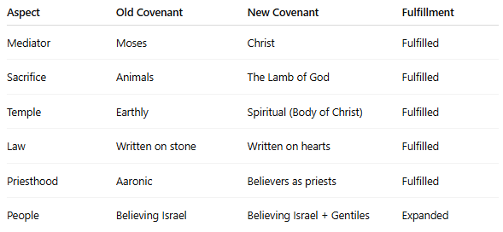
God changed the terms, not the people. He replaced the sacrifices, not the saints. He abolished the ceremonies, not the covenant of faith. The same faith line continues — never broken, never replaced.

Point 8 — The Pattern Of Scripture: Removal Of Unbelief, Continuation Of Faith
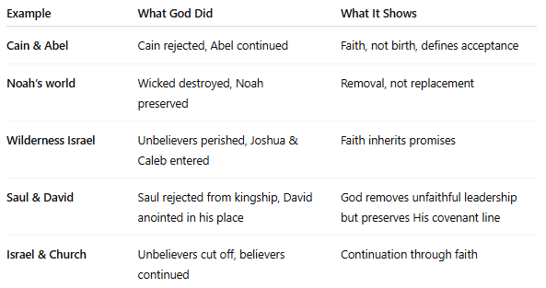

Point 9 — One Body, One Faith, One Family
""Galatians 3:28-29
There is neither Jew nor Greek, there is neither bond nor free, there is neither male nor female: for ye are all one in Christ Jesus. 29 And if ye be Christ's, then are ye Abraham's seed, and heirs according to the promise.""
There is one covenant people — all who believe in Christ. We are joined to the same root, nourished by the same promises, justified by the same faith. The Church is not a replacement for Israel; it’s the revelation of who true Israel has always been — the believers.
Spiritual Israel is just a way to refer to believers. Within physical Israel, there were believers and unbelievers. The unbelievers were a part of physical Israel that were removed from spiritual Israel because they weren't spiritual.
Spiritual Israel is equal to the church of God – the true church of God. The church today is the fulfillment of the spiritual nation of Israel. The church doesn't replace Israel. The church is the fulfillment of the spiritual nation of Israel.
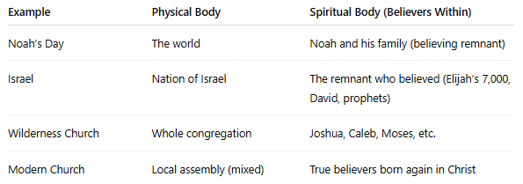
The church is the visible expression of the spiritual Israel.

Point 10 — God’s Hands Are Still Stretched Out
""Romans 10:21
But to Israel he saith, All day long I have stretched forth my hands unto a disobedient and gainsaying people.""
Even in their rebellion, God’s mercy remains extended. He hasn’t rejected them forever — He’s waiting for faith. And the same mercy offered to them is offered to all.

Conclusion — God Never Replaces, He Redeems
From Genesis to Revelation, God’s plan has never changed:
- He calls people to faith.
- He removes unbelievers.
- He preserves the faithful.
- He continues His covenant through belief.
There’s never been a “replacement theology” in the Bible — only a redemption theology.
The covenant may have changed, but the people of faith never did. They are God’s chosen, from Abel to Abraham, from David to the apostles, from the prophets to the church — one continuous body of believers, saved by grace through faith.
""Romans 11:33
O the depth of the riches both of the wisdom and knowledge of God! how unsearchable are his judgments, and his ways past finding out!""
Let's pray.

