# People In Darkness Saw Great Light

## Matthew 4:12-17

## The Perfect Life of Jesus Christ

We can learn a lot from the life of Jesus Christ. When he came to earth as God in the flesh, he made perfect decisions and lived the perfect life. He never did anything wrong. He was and is absolutely perfect.

In the Gospel of Matthew, we've seen the generation of Jesus Christ or where he came from in the flesh. We saw him being born. God protected him through many dangers such as king Herod. He was born in Bethlehem of Judah but grew up in Nazareth of Galilee. He was called a Nazarene.

John the Baptist leads the way for Jesus Christ. Jesus is baptized by John the Baptist. He is then tempted by Satan. John the Baptist is cast into prison. Now we’re going to see exactly what Jesus does here. And we're going to remember that everything he did was perfect.

## Jesus Begins His Public Ministry in Galilee

Let's see where he went and what he did.

""**Matthew 4:12**  
Now when Jesus had heard that John was cast into prison, he departed into Galilee;""

Nazareth, where Jesus was from was in the North. Jesus had went to be baptized by John the Baptist in the South in the Jordan River. Then Jesus was in the wilderness. Now he departs to go back to Galilee in the North. He was in the South in Judah. Now he's going to the North to Galilee.

""**Matthew 4:13**  
And leaving Nazareth, he came and dwelt in Capernaum, which is upon the sea coast, in the borders of Zabulon and Nephthalim:""

## The Significance of Capernaum

He goes back home to Nazareth first. He then leaves Nazareth and dwells in Capernaum. The city of Capernaum is along the sea coast. This wouldn't be the ocean. This would be the Sea of Galilee. This is in the borders of Zabulon and Nephthalim.

When the twelve tribes of Israel received their land in the promised land, Zebulon and Naphtali received land around the North and West of the Sea of Galilee. Jesus left Nazareth and went to the city of Capernaum at the Sea of Galilee.

Here's what the journey from Nazareth to Capernaum would have been like. The walk would take about 10 hours. It's about 26 miles according to Google Maps today.

Nazareth is down to the West. You can see the Sea of Galilee up there to the right. The Mediterranean Sea is to the West.

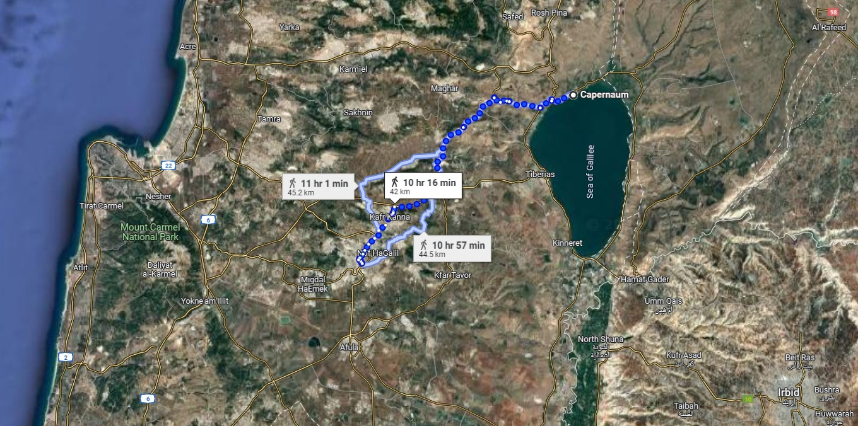

## The Geography of Jesus' Ministry

I want to show you some pictures of that path and what it looks like today.

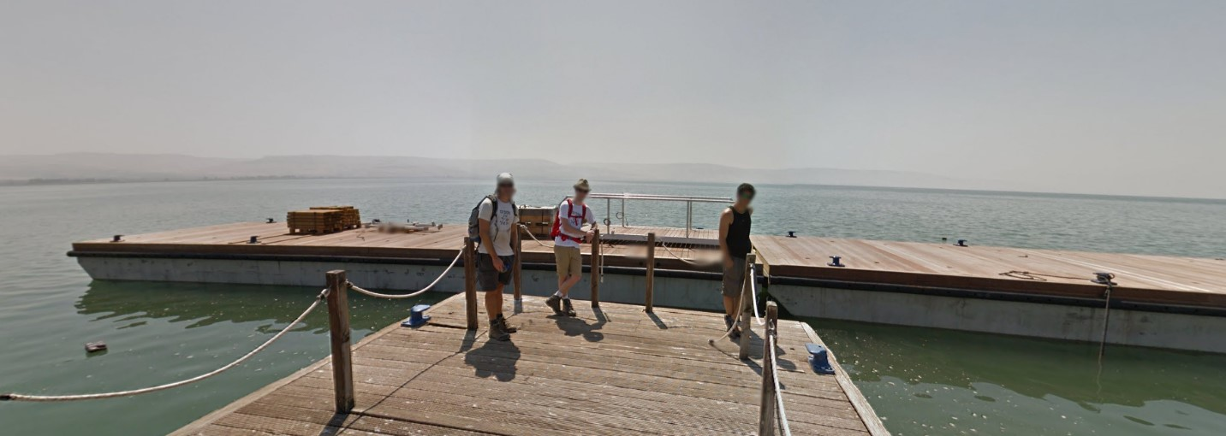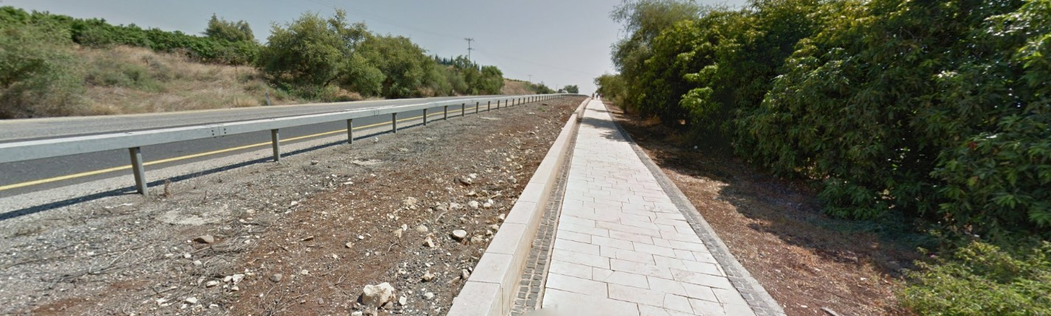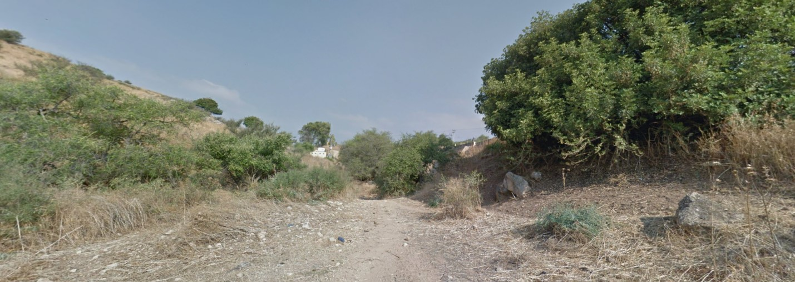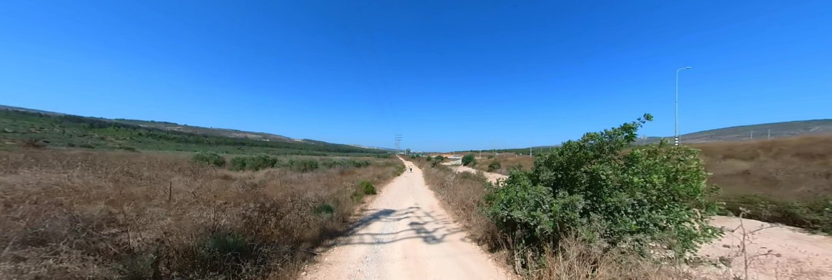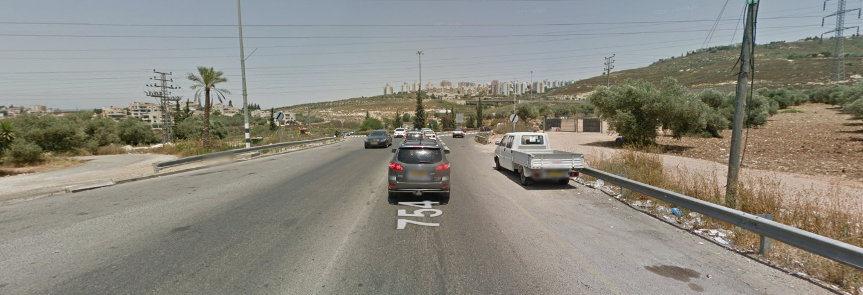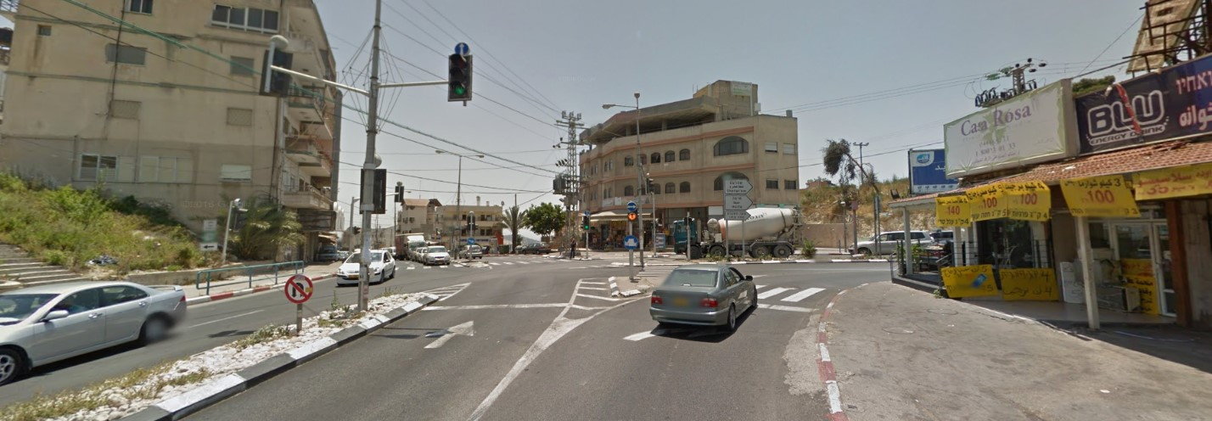

And there's the Sea of Galilee at the current day city of Capernaum which is very tiny. It presently has a population of zero. Google says it was once a village of about 1,500 people. So it was always a small town according to Google. I do not know if that information is correct.

The Bible says that Capernaum had a synagogue built by a Roman centurion. So maybe it wasn't as small as people say. But, possibly, right there in that picture, is a similar spot that Jesus found some of his disciples. They were fisherman that fished in the Sea of Galilee.

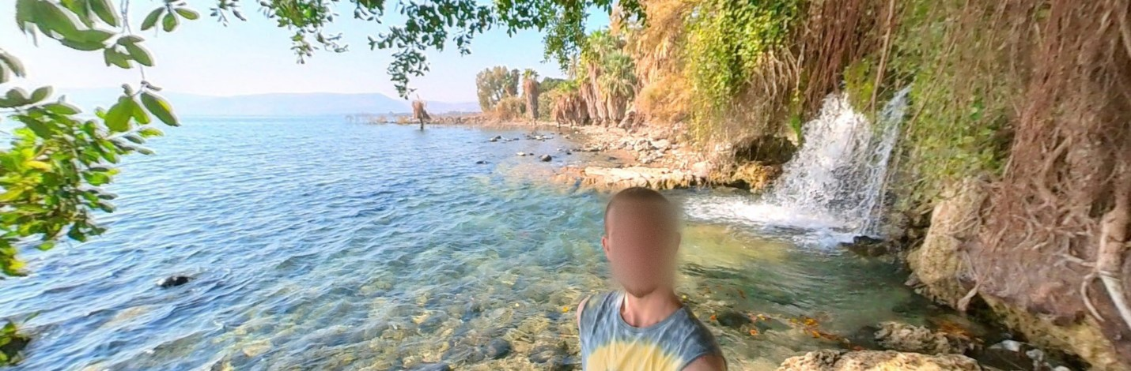

## The Sea of Galilee in Biblical History

That's another spot by the Sea of Galilee not too far from Capernaum. The Sea of Galilee is about 41,000 acres. Taylorsville Lake is about 3,000 acres. The Sea of Galilee is about 13 to 14 times bigger than Taylorsville Lake. That gives you an idea of its size. It is a freshwater lake and the lowest freshwater lake in the world in elevation.

The Sea of Galilee is known for good fishing. It's name is also known as Lake Tiberias, Lake Kinneret, and the Sea of Gennesaret. Now, remember, this is where Jesus came and dwelt for some time.

## The Fulfillment of Prophecy

""**Matthew 4:13-16**  
And leaving Nazareth, he came and dwelt in Capernaum, which is upon the sea coast, in the borders of Zabulon and Nephthalim: 14 That it might be fulfilled which was spoken by Esaias the prophet, saying, 15 The land of Zabulon, and the land of Nephthalim, by the way of the sea, beyond Jordan, Galilee of the Gentiles; 16 The people which sat in darkness saw great light; and to them which sat in the region and shadow of death light is sprung up.""

We know that Jesus came to fulfill all of the Scriptures within the Bible. Now, we see this is a quote from the Old Testament. The Bible says Esaias or Isaiah. Verse 14. Look closely again.

""**Matthew 4:14-16**  
That it might be fulfilled which was spoken by Esaias the prophet, saying, 15 The land of Zabulon, and the land of Nephthalim, by the way of the sea, beyond Jordan, Galilee of the Gentiles; 16 The people which sat in darkness saw great light; and to them which sat in the region and shadow of death light is sprung up.""

## Jesus, the Light in the Darkness

Hey, this is a great day for the people of Capernaum. The Savior of the world walks into their city. "The people which sat in darkness saw great light." The great light of Jesus Christ is here! He walks right into that city.

Imagine that. "THE" Savior of the world coming into this city of Capernaum. Jesus was always going into that city. It was written about hundreds of years earlier by the prophet Isaiah.

""**Isaiah 9:1-2**  
Nevertheless the dimness shall not be such as was in her vexation, when at the first he lightly afflicted the land of Zebulun and the land of Naphtali, and afterward did more grievously afflict her by the way of the sea, beyond Jordan, in Galilee of the nations. 2 The people that walked in darkness have seen a great light: they that dwell in the land of the shadow of death, upon them hath the light shined.""

## The Eternal Impact of Christ's Ministry

The people walked in darkness. But now they have seen a great light. They dwelled in the land of the shadow of death. But, make sure you see this, "Upon them hath the light shined."

""**John 1:5**  
And the light shineth in darkness; and the darkness comprehended it not.""

""**John 8:12**  
Then spake Jesus again unto them, saying, I am the light of the world: he that followeth me shall not walk in darkness, but shall have the light of life.""

""**John 9:5**  
As long as I am in the world, I am the light of the world.""

Jesus is the light of the world. Jesus is that light that walked into Capernaum that day. Thank God he went to Capernaum. Jesus fulfilled the prophecy from Isaiah. But that's not all he did. He is that great light. The people were in darkness.

## Darkness is the Sin and It is Blinding

The darkness is sin, unbelief, and blindness. Now think about the area we live in here. Is it in darkness? There's people being murdered all around us over and over again. It's darkness here. You can see the darkness. You can see what's being done.

Jesus starts his ministry in a dark place. Remember, we follow his lead. Jesus started in a place where many were lost in sin. We start in a place where many are lost in sin.

Jesus brought the saving light of the Gospel into the very heart of darkness.

Some people are very afraid to come here. People are afraid to go out into the streets. Women who go here are afraid to walk down the streets because of the murders and killing in the area. But, as you all know, what do we do? We go straight to the heart of the darkness with the light of Jesus Christ.

## We Go to the Heart of the Darkness with the Light

For example, a 15-year old teenager was stabbed to death by one of her best friends, an 18-year old boy. So, what do we do? We went over to that area with the Gospel of Jesus Christ. And nine children that day received the Gospel and were saved forever.

Jesus is the light of the world, but I want you to see what he says about you and I.

""**Matthew 5:14-16**  
Ye are the light of the world. A city that is set on an hill cannot be hid. 15 Neither do men light a candle, and put it under a bushel, but on a candlestick; and it giveth light unto all that are in the house. 16 Let your light so shine before men, that they may see your good works, and glorify your Father which is in heaven.""

Ye are the light of the world. Jesus put his light within us when he saved us. Now, we take that light from Jesus Christ, and we do the same thing Jesus did.

We walk right into a city like this as the light of the world. You are the light of the world. We need you to follow in the footsteps of Jesus Christ. We need you to follow us as we follow Jesus Christ.

## Jesus Christ Didn't Hide the Light from the Darkness

You don't light a candle and then hide the candle under the bushel or the frame of the candle. You set the candle stick on top of the bushel so the light shines in the darkness. The candle gives light unto all that are in the house!

Hey, let your light so shine before men! Why? So people can see. So God the Father is glorified in heaven.

So, we follow in the footsteps of Jesus. And this is real. You need to make this real in your life. As you do what God tells you to do, the Bible lights up and you'll see it so much better. It's real. This same thing is happening to us here in this city of West Louisville filled with darkness.

We bring the saving light of the Gospel of Jesus Christ into the very heart of the darkness.

We go out there soul winning almost every day. We take our Scriptures with us. We take the Scriptures written upon the tables of our heart. The Holy Spirit guides us along the way. We ask him to take us where he needs us to go. And for many of you, he guided us right to you. God loves you.

## We Follow the Guide Jesus Gave Us

Now, what do we do with what we have? We do the same thing Jesus did. We preach the Gospel. He commands us to preach the Gospel. That is the number one mission of this church. Preach the Gospel.

And we need your help. Share it with everyone you know. Invite them to church. Get them here. Tell them about Jesus Christ. The darkness is destroyed by the light of Jesus Christ.

""**Ephesians 5:8-11**  
For ye were sometimes darkness, but now are ye light in the Lord: walk as children of light: 9 (For the fruit of the Spirit is in all goodness and righteousness and truth;) 10 Proving what is acceptable unto the Lord. 11 And have no fellowship with the unfruitful works of darkness, but rather reprove them.""

Hey, we were all sometimes darkness. We've all done wrong. All of us. We are not perfect at all. But we received the light of the Gospel. "But now are ye light in the Lord."

Hey, know what you are now. You are a walking light with the truth of Jesus Christ with you.

But you have a choice. That old darkness is still there with you. The flesh is still there. "For ye were sometimes darkness, but now are ye light in the Lord. WALK AS CHILDREN OF LIGHT."

## Don't Go Back Into the Darkness

Hey, that's for you and I. We can choose to do wrong. Don't choose wrong. Get away from the darkness right now. And never go back to it. Stick with us here. We're going to work together with you. Stick with us. Get to church. Stay with us. Walk as children of the light.

For the fruit of the Spirit is in ALL GOODNESS and righteousness and truth. You have the Holy Spirit within you. Now, walk in that Spirit. Choose good. Choose right. Choose light.

"And have NO FELLOWSHIP with the unfruitful works of darkness, but rather reprove them."

Don't go the wrong way. Alcohol. Don't do it. Nastiness. Don't do it. Fornication. Don't do it. Get married and stay with that person until death do you part. Drugs. Don't do it. Gambling. Don't do it. Smoking. Don't do it. It's all going to hurt you. Don't do it. Have a clear mind. Have a mind filled with light and not darkness.

Take care of yourself. Take care of your family. Take care of your friends. Go out from here walking as the light of the world that you are. You are a part of this church that God placed here in the darkness of West Louisville.

## People In Darkness Saw the Great Light

We will be the light of the world. We will be the light of West Louisville.

We'll walk right into this city just as Jesus walked into Capernaum that day. He walked right in there. He dwelt there. He lived there. He found disciples. And they went out and did the work of God together.

""**Matthew 4:18-22**  
And Jesus, walking by the sea of Galilee, saw two brethren, Simon called Peter, and Andrew his brother, casting a net into the sea: for they were fishers. 19 And he saith unto them, Follow me, and I will make you fishers of men. 20 And they straightway left their nets, and followed him. 21 And going on from thence, he saw other two brethren, James the son of Zebedee, and John his brother, in a ship with Zebedee their father, mending their nets; and he called them. 22 And they immediately left the ship and their father, and followed him.""

That's what we need you to do. Work with us. Make the best friends you'll ever have. Come with us soul winning. Fear not, the Lord is with you.

## Jesus Walked By, Asked, They Followed

Jesus walked by. We aren't Jesus. But Jesus walked by. He sees Peter and Andrew fishing. He says, "Follow me, and I will make you fishers of men." They got up and followed him.

I'm asking you today, "Follow us, and we will make you fishers of men." Jesus gave the instructions. We know how to do it. Come here and we'll make you fishers of men.

And you have a choice. Peter got up and did it. He wasn't afraid. Andrew got up and did it. He wasn't afraid. James and John, the sons of Thunder, got up and did it. They IMMEDIATELY left the ship and followed Jesus.

Again, I'm not Jesus. But Jesus commands me to tell you this same thing. Follow us, while we follow Jesus. I'm asking you now. Will you be like Peter, Andrew, James, and John? They got up and did it. Jesus called them. They answered. Will you answer that call right now? Immediately? Or will you put it on hold for another day? That another day might not come.

## Today is the Day for Your Light to Shine

Today is the day. You have a great light within you. Get that light out. Don't hide it. Use it.

""**1 Corinthians 11:1**  
Be ye followers of me, even as I also am of Christ.""

Follow us as we follow Christ. The people in darkness, your neighbors, will see great light. It's time for the people in the darkness, who are dying and headed to hell, to see great light. We must get the light of the Gospel out into this world. Join us. Follow us.

Let's pray.