# The Feast of Firstfruits

## Leviticus 23:9-14

The feast of firstfruits happens during the seven days of unleavened bread. The Passover happens on the first day. The feast of firstfruits happens on the day after the weekly Sabbath day during those seven days of unleavened bread.

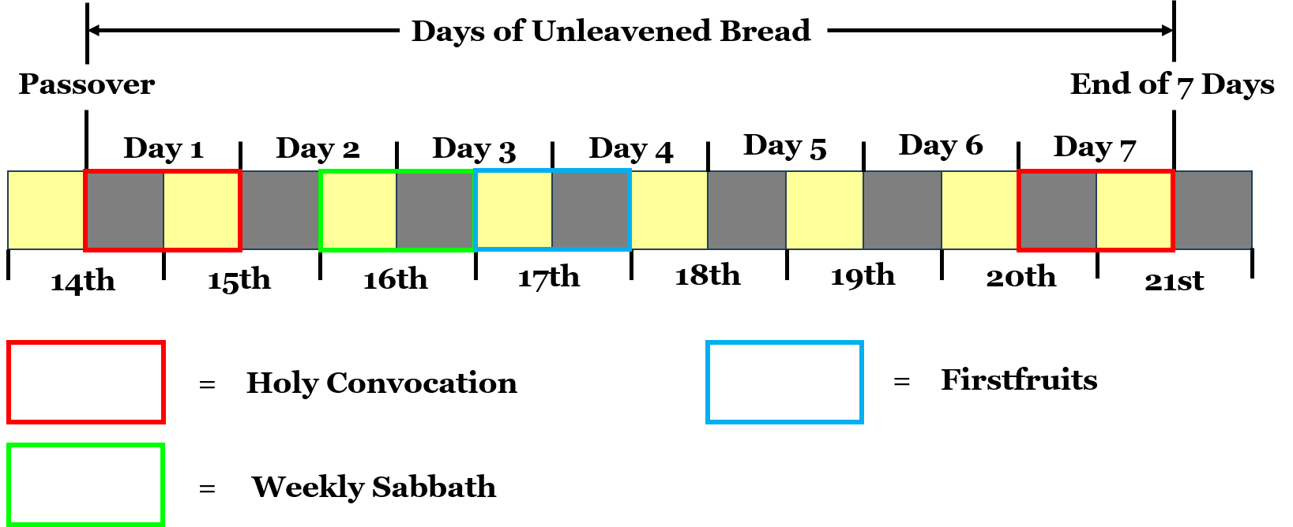

Look closely at this graphic again. At the top you see the days of unleavened bread. Seven days. You see Day 1, Day 2, all the way through Day 7. That first night of the 14th is the Passover. That's when the feast of unleavened bread begins and it continues into the day of the 15th. In that selfsame day, God brought the armies of Israel out of the land of Egypt.

## The Weekly Sabbath the Year Jesus Died

If you look at the calendar of the 16th right there, you'll see that it is a weekly Sabbath day. That's a Saturday. This is just what I believe this week looked like the year that Jesus died on the cross. The morning of the 16th, a Saturday, is when the weekly Sabbath begins. The weekly Sabbath is over when the morning of the 17th comes.

The 17th would be the first day of the week. This would be what we call a Sunday. Sunday is the first day of the week. You see the blue box there on the bottom right labeled as the Firstfruits. You see that same blue box around the day of the 17th in the year that Jesus died.

Jesus died on the 14th day of the first month a few hours before the Passover feast began. The feast of unleavened bread begins at the Passover. Jesus is dead for 3 days and 3 nights. He rises from the dead early in the morning, as the Sun rises, on the first day of the week. He arises from the dead on the day of the feast of firstfruits.

Now, here's some important points I want you to know. The feast of firstfruits is always on the day after the Weekly Sabbath. On this graphic, the weekly Sabbath is the 16th. The feast of firstfruits is on the 17th as you see there.

Early in the morning on the 17th day of the first month, Jesus rises from the dead. Jesus arose on the first day of the week. The firstfruits is ALWAYS the first day of the week.

""**Leviticus 23:10-11**  
Speak unto the children of Israel, and say unto them, When ye be come into the land which I give unto you, and shall reap the harvest thereof, then ye shall bring a sheaf of the firstfruits of your harvest unto the priest: 11 And he shall wave the sheaf before the LORD, to be accepted for you: on the morrow after the sabbath the priest shall wave it.""

## The Firstfruits is Always on the First Day of the Week

Some people will argue that the firstfruits isn't always on the first day of the week. But look closely right there again. In verse 11, the Bible says: "On the morrow after the sabbath." The firstfruits is always on the morrow after the Sabbath.

Now, I want to make a point here about the word morrow. You see the perfect word of God right there. The Bible says "on the morrow after the Sabbath." What does the word morrow mean? The definition of morrow is the next day or tomorrow. But, if we go back to the oldest English dictionary, the Samuel Johnson's Dictionary, we see this:

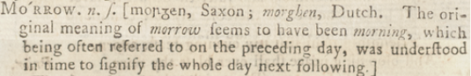

The word morrow is an old English word. The oldest English dictionary says, "The original meaning of morrow seems to have been morning, which often referred to on the preceding day, was understood in time to signify the whole next day following."

So, the definition is the next day after the present day.

## The Simple Definition of Morrow

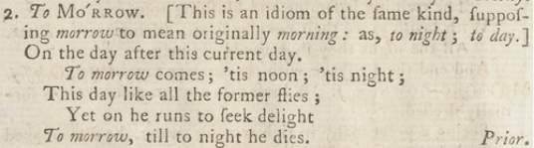

But look there again. "Morrow to mean originally morning." To morrow or the next morning. To night. To day.

Why am I stressing this? The Bible says that the feast of the firstfruits is "on the morrow after the sabbath." We know that Jesus is the firstfruits. We know that Jesus Christ arose early on the first day of the week. He arose from the dead on the morrow after the Sabbath. What does that mean? He arose early in the morning after the weekly Sabbath day had just ended.

""**Matthew 28:1**  
In the end of the sabbath, as it began to dawn toward the first day of the week, came Mary Magdalene and the other Mary to see the sepulchre.""

This entire chapter, Matthew Chapter 28, is about the resurrection of Jesus Christ. The sabbath is ending very early that next morning. The sun is dawning toward the first day of the week. The weekly Sabbath wasn't over last night. It was over when the next morning came. On the morrow after the Sabbath. We see exactly this with Jesus Christ arising from the dead.

We have another witness.

""**Mark 16:1-2**  
And when the sabbath was past, Mary Magdalene, and Mary the mother of James, and Salome, had bought sweet spices, that they might come and anoint him. 2 And very early in the morning the first day of the week, they came unto the sepulchre at the rising of the sun.""

## The Sabbath Was Past and Jesus Arose From the Dead

"And when the Sabbath was past" and "very early in the morning the first day of the week" they came unto the sepulchre at the rising of the sun.

We know for sure that Jesus arose from the dead on the first day of the week right after the weekly Sabbath day ended.

""**1 Corinthians 15:20**  
But now is Christ risen from the dead, and become the firstfruits of them that slept.""

Jesus Christ is the first to raise from the dead in a new, glorified, and incorruptible body. He is the firstfruits. And Jesus fulfills the Passover, the days of unleavened bread, and the feast of firstfruits. He is the firstfruits.

Now, let's read Leviticus Chapter 23 again and watch how this matches up perfectly with what happened on the day Jesus arose from the dead.

""**Leviticus 23:10-11**Speak unto the children of Israel, and say unto them, When ye be come into the land which I give unto you, and shall reap the harvest thereof, then ye shall bring a sheaf of the firstfruits of your harvest unto the priest: 11 And he shall wave the sheaf before the LORD, to be accepted for you: on the morrow after the sabbath the priest shall wave it.""

Again, "To be accepted for you: on the morrow after the sabbath." On the morrow, means the next morning. If I told you that I'll see you tomorrow, you know it's the next day. It's not tonight.

You need to realize what's being taught out there in churches. Lies are infiltrating the churches. Pastors are teaching these lies. We have to stop. We have to get the leaven out of the churches. We must stick to the Scriptures only. People are bring taught that a day begins at night. People have been believing this lie for decades. Our generation needs to fix that lie and teach truth.

## See You Tomorrow Means The Next Day Not Tonight

Let's say it's 10 am in the day. I look at you, and I say: "See you tomorrow." The religion of Judaism, clearly a false religion that despises Jesus Christ, will teach that a day begins at night. Tomorrow means the next day. It's 10 in our example. I look at you, and I say: "See you tomorrow."

Would anyone in their right mind think that I meant 6 pm or 7 pm or 8 pm the same day, that night? The Jews teach that a new day begins around 6 pm. If I said "See you tomorrow" I obviously mean the next day. Not that same night. It's still the same 24-hour day, and we all know it.

So, you have the weekly Sabbath day, and then you have the morrow after the Sabbath. It's the next morning after the Sabbath has ended. And that's exactly how it happens with the resurrection of Jesus Christ.

He arises from the dead on the morrow after the Sabbath. This proves he is the firstfruits. This proves that the weekly Sabbath begins on a Saturday morning and ends when Sunday morning arrives.

This proves that on the morrow means the next morning. This proves that a day begins in the morning. The first day of the week BEGAN in the morning when Jesus arose from the dead. It did not begin the prior night. All of that makes no sense. It's pure and utter confusion. The Jews love confusion. God is not the author of confusion.

## A Full 24-Hour Day Begins in the Morning

If you still don't believe that a full 24-hour day begins with the light in the morning, and you still want to argue that a day begins at night, you're going to be the one that looks foolish. There are Scriptures all throughout the Bible that teach a full 24-hour day begins in the morning and the Scriptures teach that the weekly Sabbath day begins in the morning. Watch this.

""**Exodus 16:22-23**  
And it came to pass, that on the sixth day they gathered twice as much bread, two omers for one man: and all the rulers of the congregation came and told Moses. 23 And he said unto them, This is that which the LORD hath said, To morrow is the rest of the holy sabbath unto the LORD: bake that which ye will bake to day, and seethe that ye will seethe; and that which remaineth over lay up for you to be kept until the morning.""

Focus in closely on this one. On the sixth day. What's the sixth day of the week for us? It's Friday. Saturday is the seventh day, the weekly Sabbath day, and the last day of the week. Sunday is the first day of the week.

So, on the sixth day they gathered twice as much bread. They are on the sixth day and what does Moses say right there in verse 23? "And he said unto them, This is that which the Lord hath said, "To morrow is the rest of the holy sabbath unto the Lord." We just looked at the definition of to morrow. The definition of to morrow is the next morning.

Now watch. You see that verse 23 says "To morrow is the rest of the holy sabbath unto the Lord." Moses says, "That which ye will bake to day, and seethe that ye will seethe; and that which remaineth over lay up for you to be kept UNTIL THE MORNING."

## The Sabbath Doesn't Begin at Night

Moses doesn't say to keep until tonight when the new day, the holy sabbath begins. He doesn't say that. He says the holy sabbath is beginning the next morning. The seventh day begins the next morning. The weekly sabbath day begins the morning of the seventh day. If you don't believe me still, look at the next verses.

""**Exodus 16:24-26**  
And they laid it up till the morning, as Moses bade: and it did not stink, neither was there any worm therein. 25 And Moses said, Eat that to day; for to day is a sabbath unto the LORD: to day ye shall not find it in the field. 26 Six days ye shall gather it; but on the seventh day, which is the sabbath, in it there shall be none.""

They waited until the next morning because that morning, TO DAY, Moses says, is the Sabbath unto the Lord. They didn't say TO NIGHT is the holy sabbath unto the Lord. No, the weekly sabbath day begins in the morning on the seventh day. Moses perfectly followed the instructions of the Lord. That's why it didn't stink.

If Moses thought the Sabbath day began on Friday night and only lasted to Saturday night, they would have broken the sabbath. They would have stunk to the Lord. But they didn't because they followed the sabbath correctly. They kept it the next morning.

Moses knew the weekly sabbath day began in the morning of the seventh day. That's Saturday morning. And the Bible tells us that the weekly sabbath day had just ended when Jesus arose from the dead on Sunday morning.

## A Weekly Sabbath Begins on Saturday Morning Not Friday Night

The full 24-hour weekly sabbath day, according to the Bible, begins on Saturday morning and ends on Sunday morning. Let's say, for example, Saturday morning as 6 am is the start of the weekly sabbath day, and Sunday morning at 6 am is the start of the first day of the week. The Bible clearly teaches this over and over again. And I could continue on with examples.

I've been told that I can't teach these things because it's new and no one else has ever taught this. Well, it sure looks like Moses taught that. He says it right there. Matthew wrote it in Matthew Chapter 28. It's the word of God.

Do you know how long the word of God has been around? Forever. So, has this ever been taught before? Of course. It's in the Bible. The truth has been here from the beginning. Has anyone else ever taught this? Of course. I'm not the first.

There have been thousands and thousands before me teaching this because it's right there in the Bible. And those people who taught it could actually read, study, and understand.

Back to the feast of firstfruits. We know that it begins on the morning of the first day of the week after the weekly sabbath during the seven days of unleavened bread.



The feast of firstfruits is always in the first month, the Spring time, the beginning of months. It's always after the Passover. So, if Jesus arose from the dead on the day of the feast of the firstfruits, what day do we celebrate as the resurrection of Jesus Christ?

We celebrate the resurrection of Jesus Christ as Easter Sunday. And it's always on a Sunday. It's always on the first day of the week.

## Passover: Lord's Supper & Firstfruits: Easter

We saw last week that the death of Jesus Christ happens at the Passover but Jesus Christ gives us the substitute of the Lord's Supper for the Passover. He does that Himself the night before the Passover. And now we know celebrate Easter instead of the feast of the firstfruits. And yes, I believe Easter is Biblical. I do not believe Easter is the worship of a false god.

We are going to celebrate Easter at this church. And we aren't worshipping any false gods here. Over my dead body. And we'll have an Easter egg hunt too. We aren't worshipping the goddess of fertility by putting some candy in some plastic eggs, hiding them, and allowing the children to have fun finding the eggs. We aren't bowing down to a false god. This world has lost its mind.

I don't worship false gods. I worship the Lord Jesus Christ. God wants us to enjoy this life. If you listen to the crazies out there, there would be no fun. "Oh you worship fun." What do they do? Do they sit, close their eyes, and stare into the darkness? We worship Jesus Christ. We preach Jesus Christ.

We're going to continue looking at the feasts in the Spring. The Passover, the feast of unleavened bread, the days of unleavened bread, and the firstfruits.

## Jesus is the Firstfruits and Details of His Resurrection

And I want you to keep in mind that Jesus is the firstfruits. He is the first to arise from the dead in a new, glorified, and incorruptible body. Same body but a new, glorified, and incorruptible body. In this church, we're going to take a very, very close look at all of these details.

We're going to look closely at the day Jesus arose from the dead. We're going to see exactly what happened in the Gospels. And we're going to see how Jesus is the first to arise from the dead with a new, incorruptible, and glorified body but Jesus will certainly not be the last to arise from the dead with that same type of body.

There will be more. And Jesus promises you that you will be one of those if you simply believe that He is the Savior of the world.

Let's pray.