# The Passover Lamb and Palm Sunday

## John 12:12-19

Last week we went over the Passover in detail in Exodus Chapter 12. That is the first time the Passover is ever seen. We know that the children of Israel are supposed to, in the 10th day of the first month, take to them every man a lamb, a lamb for an house.

The lamb is to be without blemish, a male of the first year, and it is to kept up until the 14th day of the first month. And then the whole assembly of the congregation of Israel shall kill it in the evening.

## The Timing of the Week of the Passover

I want to focus in on the Passover lamb today, Palm Sunday, and the timing of that week. Remember, the Passover lamb was to be taken on the 10th day of the first month and killed on the 14th day of the first month, blood was to be taken on that 14th day and apply it to the house so the angel of the Lord would see the blood and passover the homes of those people with the blood.

We know for sure that Jesus Christ is our Passover Lamb. I want to show you today that Jesus was taken on the 10th day of the first month, was kept up until the 14th day of the first month, and Jesus was killed by the entire congregation of the children of Israel on the 14th day of the first month in the evening.

The Passover in Exodus Chapter 12 is fulfilled by Jesus Christ in the New Testament.

We know, as we've already discussed, that Jesus is the Passover lamb.

John the Baptist calls Jesus the Lamb of God. In Revelation Chapter 5, Jesus is seen in heaven as a "Lamb as it had been slain." In the same chapter, a loud voice says, "Worthy is the Lamb that was slain." In Revelation Chapter 13, we see names written in the book of life of the Lamb slain from the foundation of the world.

And the Bible specifically tells us that Jesus is our passover in the New Testament. In 1 Corinthians Chapter 5, we see the words, "For even Christ our passover is sacrificed for us."

## Jesus Christ is the Passover Lamb

Jesus is our Passover lamb. We keep the Passover feast by believing in Him. What I want you to see, though, is in Exodus Chapter 12 verse 3.

""**Exodus 12:3**  
Speak ye unto all the congregation of Israel, saying, In the tenth day of this month they shall take to them every man a lamb, according to the house of their fathers, a lamb for an house:""

Now, we should see this happening in the New Testament because Jesus fulfills this. In the tenth day of the first month, a lamb is taken. That lamb is to then be kept up until the fourteenth day of the first month.

""**Exodus 12:5-6**  
Your lamb shall be without blemish, a male of the first year: ye shall take it out from the sheep, or from the goats: 6 And ye shall keep it up until the fourteenth day of the same month: and the whole assembly of the congregation of Israel shall kill it in the evening.""

This is describing Jesus Christ perfectly. He is without blemish. He's perfect. In the New Testament, Jesus is brought in by the entire congregation of Israel on the 10th day of the first month. On the 14th day of the first month, Jesus is taken and killed by the congregation of Israel in the evening.

Jesus is the Passover. He fulfills the Passover perfectly.

## Jesus Is Taken Up on the 10th Day of the First Month

Now, I want to show you in the New Testament where Jesus is taken up on the 10th day of the first month to be the Passover lamb. He comes into Jerusalem and is kept up until the 14th when he is killed on the cross. Jesus even says himself in the Gospels, "I will KEEP the passover at thy house with my disciples." He is keeping himself as the Passover Lamb.

Please see this as most people don't. I want you to know this today.

""**John 11:55-57**  
And the Jews' passover was nigh at hand: and many went out of the country up to Jerusalem before the passover, to purify themselves. 56 Then sought they for Jesus, and spake among themselves, as they stood in the temple, What think ye, that he will not come to the feast? 57 Now both the chief priests and the Pharisees had given a commandment, that, if any man knew where he were, he should shew it, that they might take him.""

The Bible says that they might take Jesus. The passover is coming, but it's not here yet. "The Jews' passover was nigh at hand." It's near, but it's not here yet. Remember, that the Passover lamb is taken on the 10th day of the first month. Remember that Jesus willingly gives himself.

That's the last Scripture in John Chapter 11. We move into John Chapter 12.

""**John 12:1-2**Then Jesus six days before the passover came to Bethany, where Lazarus was which had been dead, whom he raised from the dead. 2 There they made him a supper; and Martha served: but Lazarus was one of them that sat at the table with him.""

Now see Jesus six days before the Passover. We know the Passover begins on the 14th day of the first month at even. Right here, we know that we are six days before the Passover. Let's see that graphically to make this easier.

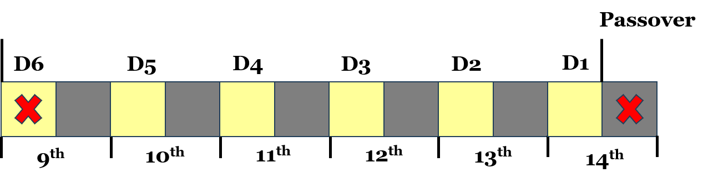

Look over to the far right. The red X on the far right represents the Passover beginning on the 14th day of the first month at even. We count back six days. You can see that count with D1, D2, D3, D4, D5, and D6. We're counting backwards from the 14th day of the first month.

## Six Days Before the Passover

Six days from the passover is on the 9th day of the first month. "Then Jesus six days before the passover came to Bethany." There Jesus eats supper. Martha served. Lazarus sat at the table with Jesus. We then see Mary anoint the feet of Jesus and wipes his feet with her hair. Jesus says, "Against the day of my burying hath she kept this."

He knows that his death, burial, and resurrection is coming in six days. We move down to verse 12 in John Chapter 12. This is what I want you to see.

""**John 12:12-13**  
On the next day much people that were come to the feast, when they heard that Jesus was coming to Jerusalem, 13 Took branches of palm trees, and went forth to meet him, and cried, Hosanna: Blessed is the King of Israel that cometh in the name of the Lord.""

Now, we were just on the 9th day of the first month. The Bible says, "On the next day." That would be the 10th day of the first month. Remember, on the tenth day of the first month, before the Passover begins, what happens?

""**Exodus 12:3**  
Speak ye unto all the congregation of Israel, saying, In the tenth day of this month they shall take to them every man a lamb, according to the house of their fathers, a lamb for an house:""

This is what's happening right there in John Chapter 12. The Lamb of God, the Passover Lamb, Jesus Christ, is willingly giving Himself up here to be the Passover Lamb that year.

""**John 12:12-15**  
On the next day much people that were come to the feast, when they heard that Jesus was coming to Jerusalem, 13 Took branches of palm trees, and went forth to meet him, and cried, Hosanna: Blessed is the King of Israel that cometh in the name of the Lord. 14 And Jesus, when he had found a young ass, sat thereon; as it is written, 15 Fear not, daughter of Sion: behold, thy King cometh, sitting on an ass's colt.""

## Palm Sunday is Five Days Before the Passover

When Jesus comes into Jerusalem, this is known as Palm Sunday. They took branches of palm trees. Palm Sunday. By definition, Palm Sunday is the Sunday before Easter. Palm Sunday is the Sunday before Easter which also happens on a Sunday. They are one week apart. One week later, Jesus rises from the dead on Easter.

We have Palm Sunday and Easter Sunday. But I want you to see this as this is very important. Many people argue the day that Jesus died on the cross. Catholics say it happened on Friday. They call it Good Friday. Many people will say it's Thursday. I say that it's Thursday. Others will say Wednesday. I want to show you how the Scriptures support Thursday.

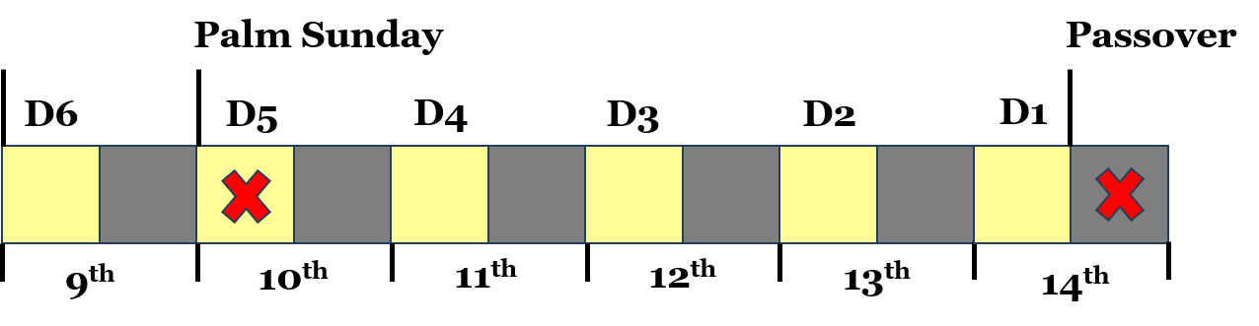

The Gospel of John is telling us that Jesus comes into Jerusalem 5 days before the Passover. I am telling you that this happened on a Sunday the 10th day of the first month. This is when Jesus is presenting himself as the Passover Lamb on the 10th day of the first month.

I would guess that a normal passover lamb would be brought, by each family, into Jerusalem on an ass or a donkey. "Fear not, daughter of Sion: behold, thy King cometh, sitting on an ass's colt." That is exactly how Jesus came into Jerusalem on the 10th day of the first month.

The Bible never calls the 10th day of the first month, when Jesus came into Jerusalem, Palm Sunday. But, I'm telling you today that this does match the Scriptures.

We know that Jesus is the Passover Lamb. We know that Jesus died on the 14th day of the first month. We know that we are 5 days before the Passover. We count back 5 days, day time, from the 14th day of the first month, as you see there in the graphic, and you get the 10th day of the first month. This is when Jesus comes into Jerusalem.

## Jesus Comes Into Jerusalem on Palm Sunday

Now, how do we know that the 10th on that graphic right there is a Sunday? We extend our graphic to the 17th day of the first month, which is one week from the 10th, and we see the next Sunday.

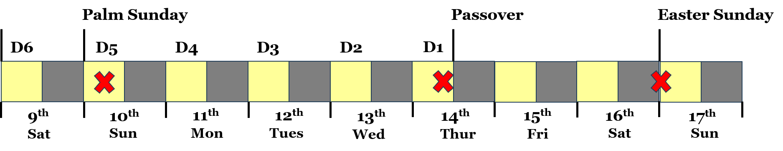

The first red X is when Jesus comes into Jerusalem on the 10th day of the first month. The second red X is when Jesus dies around 3 pm in the evening right before the Passover feast, a high day, a sabbath day, begins. The third red X is when Jesus arises from the dead.

We know that Jesus arose from the dead on the first day of the week which is Sunday. The Bible says Jesus arose directly after the weekly Sabbath ended. The weekly Sabbath day is Saturday. Once Saturday ended, the sun arose and Jesus arose on the first day of the week, Sunday.

""**Matthew 28:1**  
In the end of the sabbath, as it began to dawn toward the first day of the week, came Mary Magdalene and the other Mary to see the sepulchre.""

""**Matthew 28:5-6**  
And the angel answered and said unto the women, Fear not ye: for I know that ye seek Jesus, which was crucified. 6 He is not here: for he is risen, as he said. Come, see the place where the Lord lay.""

## Jesus Arose From the Dead on a Sunday

Jesus arose from the dead on a Sunday. Easter Sunday as you see there in this graphic.



Now, how do we know Jesus died on a Thursday as I'm showing right there?

""**Matthew 12:40**  
For as Jonas was three days and three nights in the whale's belly; so shall the Son of man be three days and three nights in the heart of the earth.""

We know Jesus was dead for three days and three nights. The Bible also tells us he was raised on the third day.

""**Matthew 16:21**  
From that time forth began Jesus to shew unto his disciples, how that he must go unto Jerusalem, and suffer many things of the elders and chief priests and scribes, and be killed, and be raised again the third day.""

""**Matthew 17:23**  
And they shall kill him, and the third day he shall be raised again. And they were exceeding sorry.""

""**Matthew 20:19**  
And shall deliver him to the Gentiles to mock, and to scourge, and to crucify him: and the third day he shall rise again.""

There are eleven more Scriptures in the New Testament that tell us Jesus arose on the third day. Now, we see that Jesus is three days and three nights in the heart of the earth and he rises from the dead on the third day.

I want you to think about this. When someone dies, what happens to their soul? A man is made up of body, spirit, and soul. The spirit is the life. When the spirit leaves the body, the body dies. Spirit and ghost are the same thing.

""**Mark 15:37**  
And Jesus cried with a loud voice, and gave up the ghost.""

## The Body, Spirit, and Soul of Jesus Christ

His body died the moment the ghost or spirit left the body of Jesus. When someone is saved, Jesus says they will never die. The spirit and soul are closely intertwined. If someone is saved, the spirit and soul will never separate meaning the soul will never die. The body dies because the spirit or ghost leaves the body.

The body of Jesus died because he gave up the ghost or the spirit or the life. Now, Jesus took the sins of the whole world onto himself being God in the flesh. Jesus had a human body, spirit, and soul. He was just like us. He came in the flesh just like us.

When Jesus died, what happened to his body, spirit, and soul? Immediately upon death, the spirit left his body. His soul left his body. Since he took the sins of the whole world onto himself, his human soul went to hell. "My God, my God why hast thou forsaken me?" Acts 2:27, Acts 2:31, Psalm 16:10 all agree that the soul of Jesus went to hell.

When did this happen? Immediately upon death. His spirit returned to God who gave it just as Ecclesiastes 12:7 says. But his soul was not left in hell. Only the word of God can divide soul and spirit.

When someone dies with sin counted to their soul, the spirit or life separates from the soul and the soul dies in hell. The spirit returns to God who gave it. So, think about this, at the moment Jesus died his soul went to hell for three days and three nights just as Matthew 12:40 says.

But what about his body? His body wasn't buried immediately upon death. His body was finally buried about 3 hours later.

""**Matthew 12:40**  
For as Jonas was three days and three nights in the whale's belly; so shall the Son of man be three days and three nights in the heart of the earth.""

This clearly, in my opinion, speaks of the soul of Jesus Christ. The heart of the earth is the center of the earth. Hell is in the center of the earth. His body didn't go down to the center of the earth. His body didn't see corruption. His soul immediately went to hell to the center of the earth.

His body wasn't immediately buried. His soul was in hell for three days and three nights. His body was buried and then arose on the third day.

Now, if we look closely at this we will see that this works perfectly.

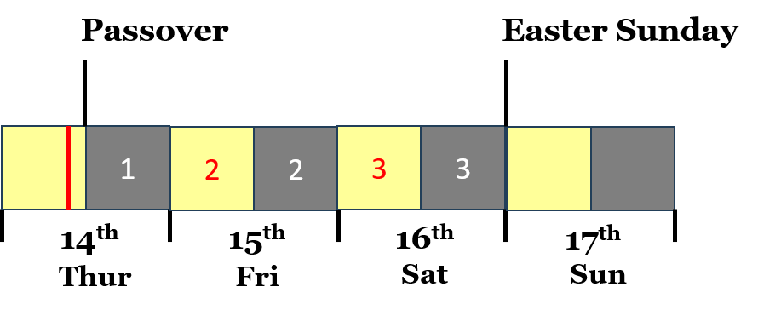

The death of Jesus occurs where that red line happens to be. That is when his soul is sent to hell because of our sin. There's a partial day, then the 2nd day in red, then the 3rd day in red. And then you see the 3 nights in white there: 1, 2, and 3. We see three days and three nights.

I believe the body of Jesus was buried just prior to the Passover Feast beginning at even. His body is raised on the third day as seen in this graphic.

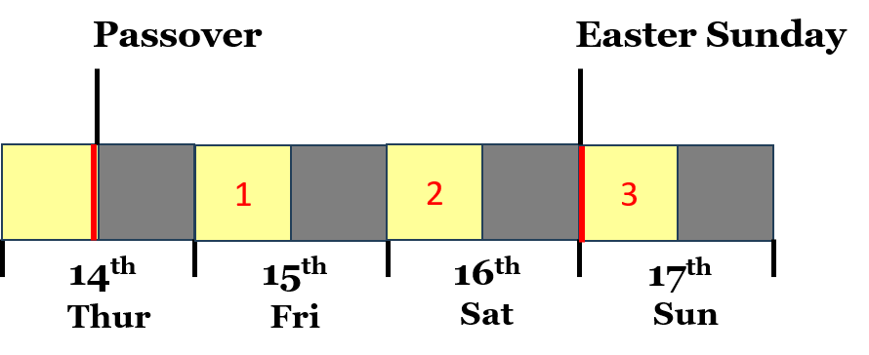

His soul was dead. His body was dead. He arises from the dead as a man in the same body but a glorified body. Thursday is the only day of the week in which three days and three nights will work and the third day will work.



If it's Wednesday, there would be four nights. If it were Friday, there would be two nights. Thursday is the only day in which it is three days and three nights and the third day. So, since Jesus had to die on a Thursday because he arose from the dead on a Sunday, this means the 14th day of the first month, the Passover, happened on a Thursday the year Jesus died.

## The Timing In The Bible is Perfect

We would count backwards to the 10th day of the first month and this would be a Sunday. Jesus came into Jerusalem on a Sunday, palm Sunday, which was the 10th day of the 1st month in the year Jesus died on the cross.

I thought that would be a fun fact for you to know that it was a Sunday when Jesus came into Jerusalem riding on an ass and presenting himself as the Passover Lamb on Palm Sunday. That was the 10th day of the month.

""**Exodus 12:3**  
Speak ye unto all the congregation of Israel, saying, In the tenth day of this month they shall take to them every man a lamb, according to the house of their fathers, a lamb for an house:""

Now you know where that's fulfilled in the New Testament, John Chapter 12, Palm Sunday.

""**Exodus 12:6**  
And ye shall keep it up until the fourteenth day of the same month: and the whole assembly of the congregation of Israel shall kill it in the evening.""

And we know that is fulfilled when Jesus dies on the cross in the evening of the 14th day of the first month, Passover Thursday.

Next time we will talk about the Lord's Supper versus the Passover. Remember, Jesus ate the Lord's Supper with his disciples the night he was betrayed. He died the next day. Jesus is the Passover, and he fulfills the Passover perfectly. If Jesus is the Passover Lamb killed the next day, how did he eat the Passover with his disciples at the Lord's Supper?

We will take a look at this in-depth Bible study next time.

Let's pray.