# The Kings in The Generation of Jesus Christ

## Matthew 1:7 – 1:11

We've been studying Matthew Chapter 1 in great detail. We know that Jesus was made of the seed of David according to the flesh. We know that Jesus is the son of Abraham and the son of David according to the flesh.

We also know that before Abraham was, Jesus was there because Jesus is God. He has no beginning and no ending. But He does have a beginning when He comes in the flesh. He was conceived of the Holy Ghost and born of the virgin Mary.

In Matthew Chapter 1, we see the physical line of Jesus Christ through Joseph. We made it to verse 6 last week.

""**Matthew 1:6-7**  
And Jesse begat David the king; and David the king begat Solomon of her that had been the wife of Urias; 7 And Solomon begat Roboam; and Roboam begat Abia; and Abia begat Asa;""

## Solomon the King and Son of David

We saw king David. He is the one that defeated Golitah as a young man. But we see the Bible says that he has a son named Solomon with a woman that had been the wife of Urias. King David committed adlutery with Bath-sheba who had a husband named Uriah.

King David had Uriah killed by placing him on the front line of a battle. The child that was conceived through adultery died. David marries Bath-sheba after Uriah is dead. And then Solomon is conceived and is born.

And, as many people, know Solomon becomes king of Israel after David.

So, I want to stop there for a minute. We see all of these people in the line of Jesus Christ doing some horrible things. We see harlots or prostitutes. We see men going after harlots or prostitutes. We see fornication which is a relationship outside of marriage. We see adultery which is a relationship with another man or woman while married.

That isn't to say that these things are okay to do. They aren't okay at all.

## Jesus Christ Was Made of This Same Flesh

The point is, though, is that Jesus Christ was made of this same flesh. He's in the physical line of people with this sinful flesh. Abraham was a sinner. David was a sinner. Jesus took on this same flesh that you and I have, the same flesh of the adulterer king David, and Jesus never once sinned.

The birth of Jesus Christ is the greatest miracle birth that will ever happen. Abraham was 100 years old when Isaac was born. You'll see miracles throughout the generation of Jesus Christ. You'll see Canaanite women and Moabite women that were not Israelites.

Jesus was made of the seed of David according to the flesh.

""**1 Timothy 3:16**  
And without controversy great is the mystery of godliness: God was manifest in the flesh, justified in the Spirit, seen of angels, preached unto the Gentiles, believed on in the world, received up into glory.""

Jesus is God manifest in the flesh. How did this work? Great is the mystery of godliness. Jesus was in this same flesh. Yet, He stayed absolutely perfect because He's God in the flesh. He came in the flesh to save us that are of this sinful flesh. He conquered it all because He's God.

So, let's start there in verse 7 of Matthew Chapter 1.

""**Matthew 1:7**  
And Solomon begat Roboam; and Roboam begat Abia; and Abia begat Asa;""

King Solomon is seen there at the beginning of the verse. He is the son of David. Solomon was the wisest man to ever live. God wrote the book of Proverbs through Solomon. God gave Solomon a huge amount of wisdom because Solomon asked for it.

## Solomon Turned Away From God When He Was Old

But, the Bible says that Solomon has 700 wives and 300 concubines. The Bible says, "When Solomon was old, that his wives turned away his heart after other gods: and his heart was not perfect with the Lord his God."

I want you to understand that none of us are even close to perfect in this flesh.

The wisest man to ever live couldn't resist the lusts of the flesh. He wanted more and more women who did not love God. Those women turned his heart from the Lord.

False preachers today, many are in the Southern Baptist religion, will teach that if you're saved that you will get better and better. They say your actions will prove that you are saved. Well, I know king Solomon was a saved man. And the Bible doesn't say he got better as got older. The Bible says, when Solomon was old, that his heart was turned from the Lord.

He turned his heart after other gods. Those other gods aren't even alive. God says, in His words, that those other gods are dumb gods. Dumb means mute, silent, not speaking. False gods can't do anything. It would be like me taking a rock outside, hanging it on the wall, and worshiping the rock, and praying to that rock. That rock doesn't do anything. It can't. It's not alive.

It's absolutely foolish to turn your heart from the Lord and worship anything else.

King Solomon, a famous king in the generation of Jesus Christ, let his flesh get the best of him. Jesus didn't. Jesus was perfect, is perfect, and will always be perfect. He's the Savior.

Since Solomon turned his heart away from God because of the many wives he took, the kingdom of Israel was split into two kingdoms. We see Israel in the North and Judah in the South.

## God Warned Solomon

God even warned Solomon and Solomon knew all of these commandments.

""**1 Kings 11:1-2**  
But king Solomon loved many strange women, together with the daughter of Pharaoh, women of the Moabites, Ammonites, Edomites, Zidonians, and Hittites; 2 Of the nations concerning which the LORD said unto the children of Israel, Ye shall not go in to them, neither shall they come in unto you: for surely they will turn away your heart after their gods: Solomon clave unto these in love.""

Solomon doesn't listen to God. Hey, it's very foolish to not listen to God and His warnings to you. When He says to not do something, don't do it. Sin turns you away from God.

""**1 Kings 11:3-4**  
And he had seven hundred wives, princesses, and three hundred concubines: and his wives turned away his heart. 4 For it came to pass, when Solomon was old, that his wives turned away his heart after other gods: and his heart was not perfect with the LORD his God, as was the heart of David his father.""

Even if you're saved, as king Solomon was, the lust of your flesh can take you away from God. When you have a weakness, stay away from it.

For example, if you love gambling, stay away from it. Don't go near it. You'll lose everything.

""**1 Kings 11:5-6**  
For Solomon went after Ashtoreth the goddess of the Zidonians, and after Milcom the abomination of the Ammonites. 6 And Solomon did evil in the sight of the LORD, and went not fully after the LORD, as did David his father.""

""**1 Kings 11:7-8**  
Then did Solomon build an high place for Chemosh, the abomination of Moab, in the hill that is before Jerusalem, and for Molech, the abomination of the children of Ammon. 8 And likewise did he for all his strange wives, which burnt incense and sacrificed unto their gods.""

Hey, Solomon even built places to worship false gods. Why? Because of his strange wives or women who didn't worship God. That's strange. For example, it's absolutely strange to set food in front of a statue you named Buddha and think that some statue is going to eat that food.

## A False God Isn’t Alive and a Statue Can’t Eat Food

Not going to happen. Now a dog or cat might come by and eat the food but that statue isn't eating that food. All other gods besides the one God in heaven are dumb gods. They are false gods. So, when Solomon did these things, do you think God was happy or angry with him? Let's see.

""**1 Kings 11:9-10**  
And the LORD was angry with Solomon, because his heart was turned from the LORD God of Israel, which had appeared unto him twice, 10 And had commanded him concerning this thing, that he should not go after other gods: but he kept not that which the LORD commanded.""

God was angry with Solomon. God had even appeared to him twice. God commanded him that he should not go after false gods. But he did it anyway. Even after the Lord appeared to him twice.

Hey, please listen to this. God warns you in your life. He says not to do this and not to do that. When you do it anway, God is not happy.

""**1 Kings 11:11**  
Wherefore the LORD said unto Solomon, Forasmuch as this is done of thee, and thou hast not kept my covenant and my statutes, which I have commanded thee, I will surely rend the kingdom from thee, and will give it to thy servant.""

Because of Solomon's choices, very bad ones, God is now angry and He's going to punish Solomon by taking the kingdom of Israel away from him.

""**1 Kings 11:12-13**  
Notwithstanding in thy days I will not do it for David thy father's sake: but I will rend it out of the hand of thy son. 13 Howbeit I will not rend away all the kingdom; but will give one tribe to thy son for David my servant's sake, and for Jerusalem's sake which I have chosen.""

## God Didn’t Take The Kingdom from Solomon Because of David

Because David, Solomon's Dad, had gotten his heart right with the Lord, God didn't take the kingdom from Solomon while he was alive. Instead he takes it out of the hand of Solomon's son. And God doesn't take the entire kingdom away because of David and because of Jerusalem.

When we go back to Matthew Chapter 1, notice the name of the son of Solomon.

""**Matthew 1:7**  
And Solomon begat Roboam; and Roboam begat Abia; and Abia begat Asa;""

We see Solomon, then Roboam, then Abia, and then Asa. These are kings that you'll read about in the Old Testament. We saw king David, then king Solomon, and now king Roboam who is the son of Solomon.

When Solomon dies, Reheboam or Roboam reigns as king of Israel in the city of David. You'll find more information about all of these kings in the books of 1 Kings, 2 Kings, 1 Chronicles, and 2 Chronicles.

Reheboam, the son of Solomon, becomes king and then soon after the kingdom is divided. Israel in the North and Judah in the South. Roboam is the king in the South in the kingdom of Judah.

## The Kingdom is Divided Because of Solomon’s Sin

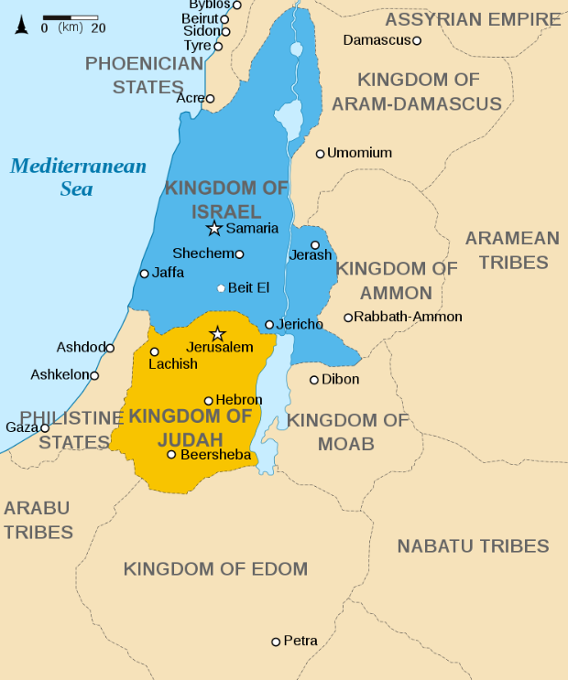

This is just an approximate map of the Northern Kingdom in the blue there, the Kingdom of Israel once it was divided because of Solomon's sin. And you see the Southern Kingdom, in the yellow or gold there, the Kingdom of Judah.

So, the kings you see listed in Matthew Chapter 1, after king Solomon, are from that Southern Kingdom of Judah.

Remember, Jesus, in the flesh, comes from the tribe of Judah. David was from the tribe of Judah. Solomon was from the tribe of Judah.

""**Matthew 1:7**  
And Solomon begat Roboam; and Roboam begat Abia; and Abia begat Asa;""

## More Kings in the South Country of Judah

We see Solomon, then Roboam the first king of Judah in the divided kingdom. When this kingdom splits, the Northern Kingdom has a line of kings until that kingdom is eventually destroyed by the Assyrians. There was not one good king mentioned in that Northern Kingdom. Not one.

That Southern Kingdom of Judah had a long line of kings. Some of them were good kings and some of them were bad kings.

In verse 7 right there, we see Roboam, Abia, and Asa mentioned.

Solomon's son, Reheboam, do you think he was a good king or a bad king? Remember, reading your Bible is very important. Staying in the word of God constantly is very important. Reading through the Bible over and over again is very important. And don't stop.

Reheboam is not a good king. Judah did evil in the sight of the Lord while he reigned.

The next king you see there is Abijah or Abia. He was the son of Reheboam. Not a good king. The Bible says he walked in all the sins of his father, which he had done before him.

After Abia, you see Asa.

""**1 Kings 15:11-12**  
And Asa did that which was right in the eyes of the LORD, as did David his father. 12 And he took away the sodomites out of the land, and removed all the idols that his fathers had made.""

And remember, these are kings that had power to do these things.

The Bible specifically mentions that Asa was a good king. He did that which was right in the eyes of the Lord. What were some of his biggest accomplishments? The Bible, God Himself, says that Asa took away the sodomites out of the land and removed all the idols.

## Removing Sodomites of the Land Was a Good Thing

Sodomites are those who commit the act of sodomy. That's men with men and women with women. King Asa removed those people out of the land. And God says it was a good thing. God is not for those things. He says that it is an abomination which He greatly hates. Men don't go with me. It doesn't work. Women don't go with women. It doesn't work.

Along with those things comes idols. Asa removed the idols. No more of that. And God said he was a good king that did right. But listen to this.

Asa's father was not a good king. He walked in all the sins of his father. Asa's grandfather was not a good king. How did Asa turn out to be a good king? Maybe his mother was good?

""**1 Kings 15:13**  
And also Maachah his mother, even her he removed from being queen, because she had made an idol in a grove; and Asa destroyed her idol, and burnt it by the brook Kidron.""

Asa's mother even made an idol to worship. He removed her from being queen. He didn't have a good Dad. He didn't have a good Mom. But he knew the Lord. So, he had the choice to make. Hey, you've got the choice to make.

Maybe you dont't have a good Dad as king Asa. Maybe you don't have a good Mom as king Asa. But you have that same choice as Asa had.

## You Get the Same Choice Those Kings Had

Are you going to choose to do right or wrong with your life? Asa chose right. If you've done wrong in your life, that's in the past. It's time to get it right, RIGHT NOW! I've done wrong in my life. I'm getting it right, RIGHT NOW. You have that choice right now.

I know you're here trying to do good. And I see that. And God sees that more than I do. He knows you. He wants you to continue doing good. And I want you to continue. Stay consistent. Let's do right together. Continuing in Matthew Chapter 1.

""**Matthew 1:8**  
And Asa begat Josaphat; and Josaphat begat Joram; and Joram begat Ozias;""

We see four more kings listed here. Asa who we just talked about. Josaphat. Joram. Ozias. In the Old Testament, these are known as Asa, Jehoshaphat, Jehoram, and Uzziah.

Jehoshaphat is a good king, the son of Asa. Joram or Jehoram is not a good king. And then we see Ozias at the end of the verse. There is a mystery within this verse. Ozias is not the direct son of Joram as the others listed here are direct sons.

People believe different things when you come to this point in the Bible.

There are three kings missing from this generation of Jesus Christ between Joram and Ozias or Uzziah. They are listed in other parts of the Bible, but they aren't listed here. This is a mystery that we will study more in the future.

## Several Kings Were Taken Out of the Generation of Jesus Christ

But, we know, for a good reason, they were taken out of the generation of Jesus Christ. Three kings, Ahaziah, Jehoash or Joash, and Amaziah were removed from this generation of Jesus Christ in Matthew Chapter 1.

There are a couple more later on that aren't listed in this chapter either.

We will continue from this point next week. Remember, we're going verse by verse through the Bible for Sunday School. We are in Matthew Chapter 1.

Let’s pray.