# Work First and Rest Second

## Genesis 8:20-22

Last week we looked at the first day. In Genesis Chapter 1 verse 5, we saw that God created the first 24-hour day.

He called the light Day and the darkness He called night in that order. Day first. Night second. Light first. Darkness second.

""**Genesis 1:14-15**  
And God said, Let there be lights in the firmament of the heaven to divide the day from the night; and let them be for signs, and for seasons, and for days, and years: 15 And let them be for lights in the firmament of the heaven to give light upon the earth: and it was so.""

## Day is First and Night is Second

Day is seen first in these Scriptures. Night is seen second.

""**Genesis 1:16-18**  
And God made two great lights; the greater light to rule the day, and the lesser light to rule the night: he made the stars also. 17 And God set them in the firmament of the heaven to give light upon the earth, 18 And to rule over the day and over the night, and to divide the light from the darkness: and God saw that it was good.""

Again, we see day first and night second in these Scriptures. "And to rule over the DAY and over the NIGHT, and to divide the LIGHT from the DARKNESS."

Day is first. Night is second. Morning is first. Evening is second. Light is first. Darkness is second. This is God's order that He created.

Today, I want to show you that work is first and rest is second, in that same order as day and night, morning and evening, light and darkness. We work. Then we rest.

We're going to look out a how a day works, how a week works, how a year works with the seasons, and how seven years work. And within all these examples, you're going to see the perfect order within God's creation.

## God's Order for a Day, Week, Year, and Seven Years

Again, we are looking at the order of the following:

1. Day
2. Week
3. Year
4. Seven Years

""**Genesis 1:5**  
And God called the light Day, and the darkness he called Night. And the evening and the morning were the first day.""

The first day ever created, according to God, consists of the Day and then the Night. We are to work in the day and rest at night. When evening arrives, this is when darkness arrives. From evening to morning, we rest because it's night.

""**Genesis 2:2**  
And on the seventh day God ended his work which he had made; and he rested on the seventh day from all his work which he had made.""

The Bible says, "And on the seventh DAY God ended his work which he had made." He rested on the seventh DAY because He didn't work during that DAY time of that full 24-hour DAY.

## We Work During the Day When There is Light

The Bible says over and over again that we work during the day.

""**John 9:4**  
I must work the works of him that sent me, while it is day: the night cometh, when no man can work.""

The order within that verse is day and then night. We work during the day. Rest during the night. We work first in the day and then rest the remainder of the day.

""**John 11:9-10**  
Jesus answered, Are there not twelve hours in the day? If any man walk in the day, he stumbleth not, because he seeth the light of this world. 10 But if a man walk in the night, he stumbleth, because there is no light in him.""

Again, we see 12 hours in the day FIRST. We see night second. When we wake up each morning, we know it's time to get up and work. It's natural. And then we work all day long and we're tired. It's natural. We want to rest at night. We sleep at night. Work hard during the day and rest at night in that order.

""**Leviticus 6:20**  
This is the offering of Aaron and of his sons, which they shall offer unto the LORD in the day when he is anointed; the tenth part of an ephah of fine flour for a meat offering perpetual, half of it in the morning, and half thereof at night.""

We know a full 24-hour day begins in the morning and ends the next morning. We know the second half of a day begins in the evening when darkness comes. First half of the day is light. Second half of the day is dark.

That verse says, "which they shall offer unto the Lord in the DAY when he is anointed." And then we see "half of it in the morning" and "half of it at night." It's still the same day. Remember, the Jews say that a day begins at night. That's not what this verse says.

## The Weekly Sabbath is Ending When It is Dawning Towwards the First Day of the Week

""**Matthew 28:1**  
In the end of the sabbath, as it began to dawn toward the first day of the week, came Mary Magdalene and the other Mary to see the sepulchre.""

This verse says the weekly Sabbath day is ending because Jesus arose on the first day of the week. The Sabbath day is the last day in every week. The Sabbath day was ending as it was dawning toward the first day of the week.

So a day doesn't begin at night or this verse wouldn't make any sense at all.

""**Leviticus 23:5**  
In the fourteenth day of the first month at even is the LORD'S passover.""

According to the Jews day, a day begins at even or evening when it's dark. So, what exact day and time would this be? This is very confusing. The religion of Judaism is filled with lies and confusion. God is not the author of confusion.

"In the fourteenth day of the first month at even is the Lord's passover."

## When is Evening on the 14th Day of the First Month?

According to the Jewish way of a day beginning in the evening, tell me which point on this image is the fourteenth day of the month at evening?

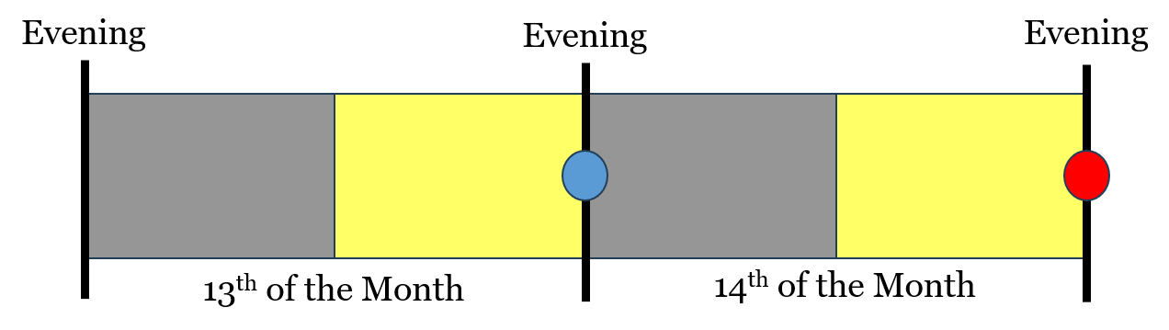

Is the blue dot the 14th day of the month at evening or is the red dot the 14th day of the month at evening? When does the Passover begin? At the blue dot or at the red dot? You can argue all day long about this. It's pure confusion.

But, let's look at the Biblical way of looking at a day. A Day begins in the morning and not in the evening. When evening comes, we don't say: "It's a new day!" A new day doesn't come with darkness. A new day comes with light the next morning.

Now, tell me where the 14th day of the month is at evening in this picture.

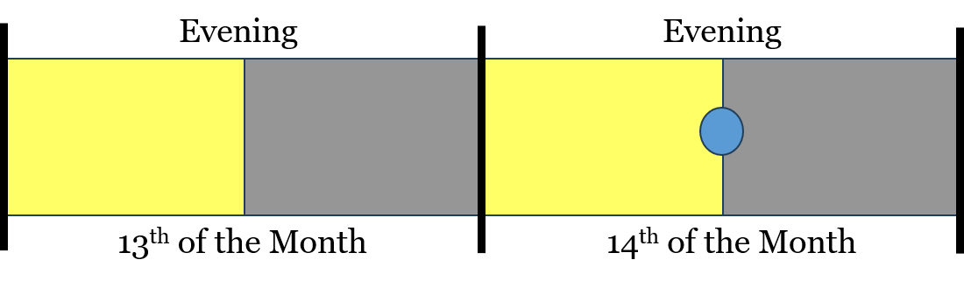

There's only one option now. The 14th day of the month starts in the morning when the light comes. On the 14th day of the month, at evening, the Passover begins. You only have one option. The Passover is a night to remember. When that night is over and morning comes, the 14th is over and the 15th day of the month begins in the morning.

## God is Not the Author of Confusion for the 14th Month at Evening

God is not the author of confusion. He explains the order of a day with day first and night second. This is why a full 24-hour Day is called a Day because it begins in the Day and ends after Night is finished. A new Day begins the next morning with the light.

That's just another example proving that a Biblical day begins in the morning with light. We work in the day and we rest in the night.

""**Ecclesiastes 5:12**  
The sleep of a labouring man is sweet, whether he eat little or much: but the abundance of the rich will not suffer him to sleep.""

Focus in on the first part of that verse. "The sleep of a labouring man is sweet." A man works hard during the day. This is when he labors. Jesus said, "I must work the works of him that sent me, while it is day: the night cometh, when no man can work."

A man works during the day when he can see. Then he sleeps at night. "The sleep of a labouring man is sweet." This is logical and in perfect order.

""**Genesis 31:40**  
Thus I was; in the day the drought consumed me, and the frost by night; and my sleep departed from mine eyes.""

Day and then night. Work in the day and sleep in the night. Okay, I could continue on and on but I'm moving on to the next point. Remember, we work first and we rest second. That's what happens in a normal day.

God worked in the day during the six days of creation. That's what "And the evening and the morning were the first day means." He worked. When evening arrived, he stopped working.

## God Created Seven Days in a Week

Now, we looked at a day in detail. Let's look at a week. There are seven days in a week. God made seven days in a week, and His creation is still going like this. We have a seven day week.

God worked the first six days of the week and then He rested on the seventh day. Work came first and then rest came second. Just as with every full 24-hour day, work comes first and then rest comes second.

""**Leviticus 23:3**  
Six days shall work be done: but the seventh day is the sabbath of rest, an holy convocation; ye shall do no work therein: it is the sabbath of the LORD in all your dwellings.""

This is very easy to see. During the day on the seventh day, no work shall be done. All of the other days work shall be done. We work six days and rest on the seventh day. I want you to see this order of God's creation. WORK FIRST. REST SECOND. Work then rest.

So far, we see this order of WORK then REST in a 24-hour DAY and in a 7-day WEEK. Work in the day, rest in the night. Work six days, rest the seventh day.

Now, let's look at a full year. Within a year, we have four seasons. Think about the land during these four seasons. The Bible says that a year begins in the Spring.

In Exodus Chapter 12, we know this to be the Passover chapter in the Bible.

""**Exodus 12:1-2**  
And the LORD spake unto Moses and Aaron in the land of Egypt, saying, 2 This month shall be unto you the beginning of months: it shall be the first month of the year to you.""

God says, the month of the Passover is the FIRST MONTH of the year.

""**Deuteronomy 16:1**  
Observe the month of Abib, and keep the passover unto the LORD thy God: for in the month of Abib the LORD thy God brought thee forth out of Egypt by night.""

## A New Year Begins in the Spring According to the Bible

We know the Passover occurs in the Spring. So, a new year begins in the Spring. Our current calendar is wrong as we say a year begins in January, in the winter. January came much later and is said to have started when a Roman ruler added January and February. The month January was supposedly named after Janus the Roman false god of beginnings.

We know, according to God that a year begins in the Spring. This makes perfect sense because this is when things begin to grow again. It's a beginning. It's a new start. All the plants and trees are blooming. Makes perfect sense and is in perfect order just as God created.

So, a year begins in the Spring. The land is beginning to work. Watch what this next verse says closely.

""**Genesis 8:22**  
While the earth remaineth, seedtime and harvest, and cold and heat, and summer and winter, and day and night shall not cease.""

We see things in God's perfect order here. We see seedtime and harvest in that order. Obviously, seedtime must come before harvest. If you don't have seedtime first, you aren't having any harvest.

We also see summer and winter here. Summer comes before winter. The Bible says so. In our current calendar, we see Winter first when a new year begins and then Summer later. This is wrong. Summer comes before Winter in God's eyes. And His eyes see truth.

At the end of that verse, we see day and night, in that order. Day is first and night is second.

## Spring is First, Summer Next, Fall Afterwards, and Lastly Winter

In a Biblical year, we see Spring first, Summer next, Fall after that, and then Winter. The point of this is that the land is working hard in the Spring, Summer, and Fall. When Winter comes, the land rests. You see work first and then rest second.

In a day, man works and then sleeps. In a week, man works and then rests. In a year, the land works and then sleeps.

""**Psalm 74:17**  
Thou hast set all the borders of the earth: thou hast made summer and winter.""

Summer first. Winter second. In that order. Not winter first. God says so when He set the first month. The Passover occurs in the Spring time. That is the beginning of months.

""**Song of Solomon 2:11-12**  
For, lo, the winter is past, the rain is over and gone; 12 The flowers appear on the earth; the time of the singing of birds is come, and the voice of the turtle is heard in our land;""

The time of singing is come. In Winter, we see more darkness. When the new year comes, the flowers appear on the earth, and the time of the singing birds is come. Winter is a time of rest and it is the end of every year according to the Bible.

Spring is seedtime. Then Summer. Fall is harvest. Winter is when the land rests. For example, on a cattle farm, you must have hay for the winter because the grass isn't growing. It's resting.

Again, I am showing you the order of God's creation. Work and then rest. Day and then night. Six days of work and then rest on the seventh day of the week. Work and then rest. Spring or seedtime, Summer, Fall or harvest, and then Winter. Work and then rest.

## The Seven Year Cycle Created by God Himself

Now, the final example I want to show you is the seven year-cycle created by God.

""**Exodus 23:10-11**  
And six years thou shalt sow thy land, and shalt gather in the fruits thereof: 11 But the seventh year thou shalt let it rest and lie still; that the poor of thy people may eat: and what they leave the beasts of the field shall eat. In like manner thou shalt deal with thy vineyard, and with thy oliveyard."

Six years the land works. In the seventh year, the land rests. Don't sow in the land during that seventh year.

""**Leviticus 25:1-4**  
And the LORD spake unto Moses in mount Sinai, saying, 2 Speak unto the children of Israel, and say unto them, When ye come into the land which I give you, then shall the land keep a sabbath unto the LORD. 3 Six years thou shalt sow thy field, and six years thou shalt prune thy vineyard, and gather in the fruit thereof; 4 But in the seventh year shall be a sabbath of rest unto the land, a sabbath for the LORD: thou shalt neither sow thy field, nor prune thy vineyard.""

""**Leviticus 25:5-7**  
That which groweth of its own accord of thy harvest thou shalt not reap, neither gather the grapes of thy vine undressed: for it is a year of rest unto the land. 6 And the sabbath of the land shall be meat for you; for thee, and for thy servant, and for thy maid, and for thy hired servant, and for thy stranger that sojourneth with thee, 7 And for thy cattle, and for the beast that are in thy land, shall all the increase thereof be meat.""

God told them to not sow in the land in that seventh year. This is modeled after the 7-day week. Six days of work and the seventh day of rest. Six years of work and the seventh year of rest.

"It is a year of rest unto the land. And the sabbath of the land shall be meat for you."

## Work First and Rest Second In That Order

Again, the order of God's creation is work and then rest. When a new day comes in the morning, you have a fresh start after a night of rest. When a new week comes, you have a fresh start after a day of rest. When a new year comes, you have a fresh start after a winter of rest. I wanted you to see this and learn from this.

This is simply more proof that a day begins in the morning and not at night. And we're going to need to know this fact and this truth as we continue to study.

Remember, we're heading to the feasts of the Lord. We cannot get the timing of the feasts of the Lord correct without knowing the order of day and night in the Bible.

Let's pray.