# Day vs. Night

## Matthew Chapter 28

I want to start with something simple for this first Thursday night Bible study. But sometimes simple things are made difficult with religion and false teaching from the Bible.

This simple teaching will lead to a better understanding of more diffciult things within the Bible.

Day vs. Night.

That's the topic we're starting with and this is very important to understand as this simple doctrine affects many beliefs that people have about many different passages in the Bible.

## At What Point Does a 24-Hour Day Begin?

Here's a question for you:

When does a day begin? When does a new day begin? I'm talking about a 24-hour day.

We're going to go through the entire Bible studying this topic for as long as it takes for us to fully understand when a day begins.

I was taught, online by many pastors and preachers in the past, that a day begins at night. I've even taught that myself years ago because I thought it was correct. I trusted those pastors. And I am sure they didn't teach it wrong on purpose.

When I taught it, I didn't teach it wrong on purpose. I thought I was right. It's easy for me to admit I was wrong because I'm just a man.

The Bible teaches us the truth. We must humble ourselves to the word of God because God knows more than us. And He wrote it all down for us to see. And to teach us. We must rely on the Bible alone to find the truth.

So, when does a day begin?

Is it the morning when the sun comes up? Is at night as the Jews believe a day begins? Is it when the sun goes down? Is it 12 AM as our current tradition in this country? Midnight? Midday? Morning, evening, afternoon?

## The Bible Tells Us When a New Day Begins

We're going to go through the entire Bible and see what God says.

""**Matthew 28:1**  
In the end of the sabbath, as it began to dawn toward the first day of the week, came Mary Magdalene and the other Mary to see the sepulchre.""

Every word of God is profitable for doctrine. This Scripture right there is pure 100% truth. It came straight from the mouth of God Almighty.

I've read that verse scores and scores of times before. I'm sure you have too. This is the day Jesus arose from the dead. One of the greatest days ever.

But look closely there. My job here is take the Bible and give you simple truths from God's word. This is how we learn. This is how we remember. This is how we grow our faith in God and His words.

"In the end of the sabbath."

We know this is resurrection day for Jesus Christ. We know He arose from the dead on the first day of the week. We know the Sabbath day is ending as the Bible says, "In the end of the Sabbath."

## Which Day of the Week is the Sabbath Day?

Which day is the Sabbath day because that day is ending according to Matthew 28:1? Let's see.

""**Genesis 2:2-3**  
And on the seventh day God ended his work which he had made; and he rested on the seventh day from all his work which he had made. 3 And God blessed the seventh day, and sanctified it: because that in it he had rested from all his work which God created and made.""

Now, the first use of the word Sabbath isn't until Exodus Chapter 16. We don't see the word Sabbath right there in Genesis Chapter 2.

But, we know that God created everything in 6 literal 24-hour days and on the seventh day He rested. The seventh day is the day of rest. That is the Sabbath day. The seventh day of the week.

We have a seven day week. Why do you think we have a seven day week? God created the 7-day week. And it's still going strong.

Sunday is the first day of the week. Monday is second, Tuesday is third, Wednesday is fourth, Thursday is fifth, Friday is sixth, and Saturday is the seventh and final day of the week.

## The Sabbath Day is Saturday

So, the Sabbath day would be the seventh DAY, which would be a Saturday. Jesus arose from the dead on the first day of the week. The first day of the week is a Sunday. We worship on Sunday.

Let's look at the first use of the word Sabbath in the Bible. And this is very important.

""**Exodus 16:22-23**  
And it came to pass, that on the sixth day they gathered twice as much bread, two omers for one man: and all the rulers of the congregation came and told Moses. 23 And he said unto them, This is that which the LORD hath said, To morrow is the rest of the holy sabbath unto the LORD: bake that which ye will bake to day, and seethe that ye will seethe; and that which remaineth over lay up for you to be kept until the morning.""

The Bible says there in verse 22, "that on the sixth day they gathered twice as much bread."

Verse 23 says, "To morrow is the rest of the holy sabbath unto the Lord."

"That which remaineth over lay up for you to be kept until the morning." That next morning is the Sabbath day.

## Saturday Begins on Saturday Morning as the Sun Rises

The Sabbath day is on the seventh day. It's not on the sixth day. Saturday is the seventh day. Saturday is the Sabbath day or seventh day. Sunday is the first day of the week.

So, let's think about that question again:

When does a day begin?

""**Matthew 28:1**  
In the end of the sabbath, as it began to dawn toward the first day of the week, came Mary Magdalene and the other Mary to see the sepulchre.""

The Bible, the word of God, straight from the source of all truth, says:

"As it began to dawn toward the first day of the week."

The Bible says, "In the end of the sabbath." The sabbath day is ending. And the new day is beginning.

## Dawning Towards The First Day of the Week

The seventh day is ending. The first day of the week is here. It's dawning towards the first day of the week.

The definition of dawn, according to the oldest English dictionary:

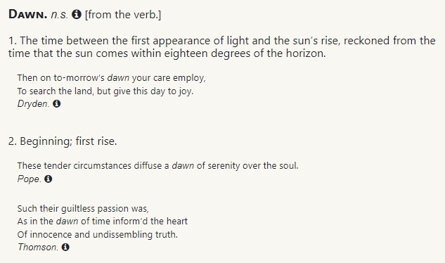

Dawn is the time between the first appearance of light and the sun's rise. Dawn means beginning or first rise.

So, the beginning of the first day of the week is here.

The sun is a picture of Jesus Christ.

""**Malachi 4:2**  
But unto you that fear my name shall the Sun of righteousness arise with healing in his wings; and ye shall go forth, and grow up as calves of the stall.""

Notice this is referring to Jesus Christ as the Sun, S-U-N, the Sun of righteousness. He will arise the Bible says.

I believe Jesus Christ arose from the dead as the sun arose on that first day of the week. The light of the world arose from the darkness, from the dead. Everything God does is perfect.

## The Sabbath Day Ended and Then Jesus Arose From the Dead

So, the sabbath day ended and then Jesus arose from the dead as the sun arose on the first day of the week.

Let me make sure I've explained this correctly by asking you that question again. Now you've seen what the Bible is clearly teaching.

When does a day begin accoording to the Bible? When does a day begin according to Matthew 28:1? Let's look at that verse once again.

""**Matthew 28:1**  
In the end of the sabbath, as it began to dawn toward the first day of the week, came Mary Magdalene and the other Mary to see the sepulchre.""

What time of day are we at here in the Scriptures? We are at the end of one day and the beginning of the next day.

The 7th day of the week, Saturday, the Sabbath is ending. And the first day of the week, Sunday, is coming. It is dawning towards the first day of the week. The light is here. Jesus Christ is here. As Jesus Christ comes, the light comes.

The Sun, S-U-N, is a picture of Jesus Christ. The sun is too bright to look upon. God is too bright to look upon. Jesus is the Son of God. He came forth from God. He is God.

When the sun comes up, the morning is here. A new day is here. Makes perfect sense, right?

## You Should Know When a Sabbath Day Begins

Again, why am I teaching this? This is of utmost importance to understand many different doctrines within the Bible. For example, it's good to know when the Sabbath day begins and ends so you can understand those Scriptures when you get to them.

Understanding the Scriptures increases your faith in God. Wisdom is increased.

We will be able to understand the feasts of the Lord by knowing that a day begins in the morning. We will be able to understand the Passover, the days of unleavened bread, the day of atonement, and more. We are going to do detailed studies on the feasts of the Lord.

Knowing that a day begins in the morning will help you to disprove false doctrine.

For example, in the religion of Judaism today, they start their Sabbath day on Friday night. They say the weekly Sabbath day begins every Friday night and ends Saturday night. Seventh Day Adventists, a false religion, practice the Sabbath from Friday night to Saturday night.

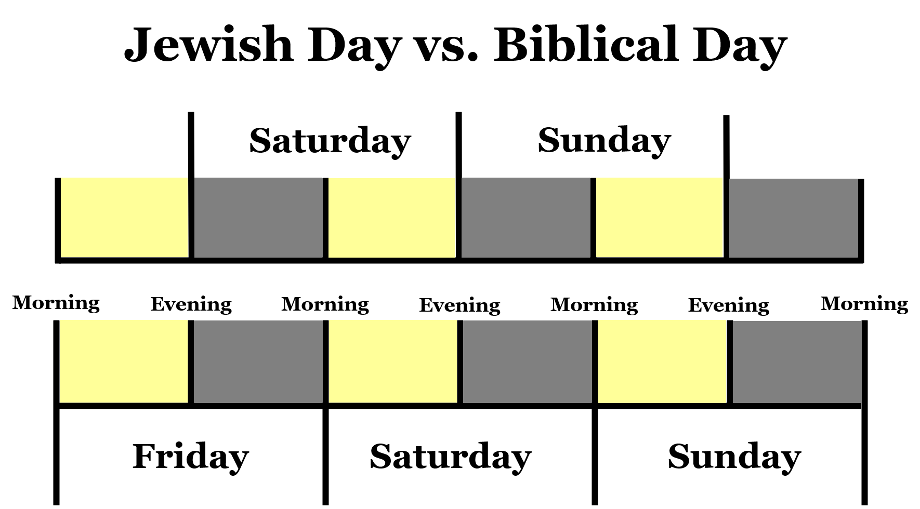

The religion of Judaism is a false religion. And they are backwards when it comes to day vs. night because they are the children of the night.

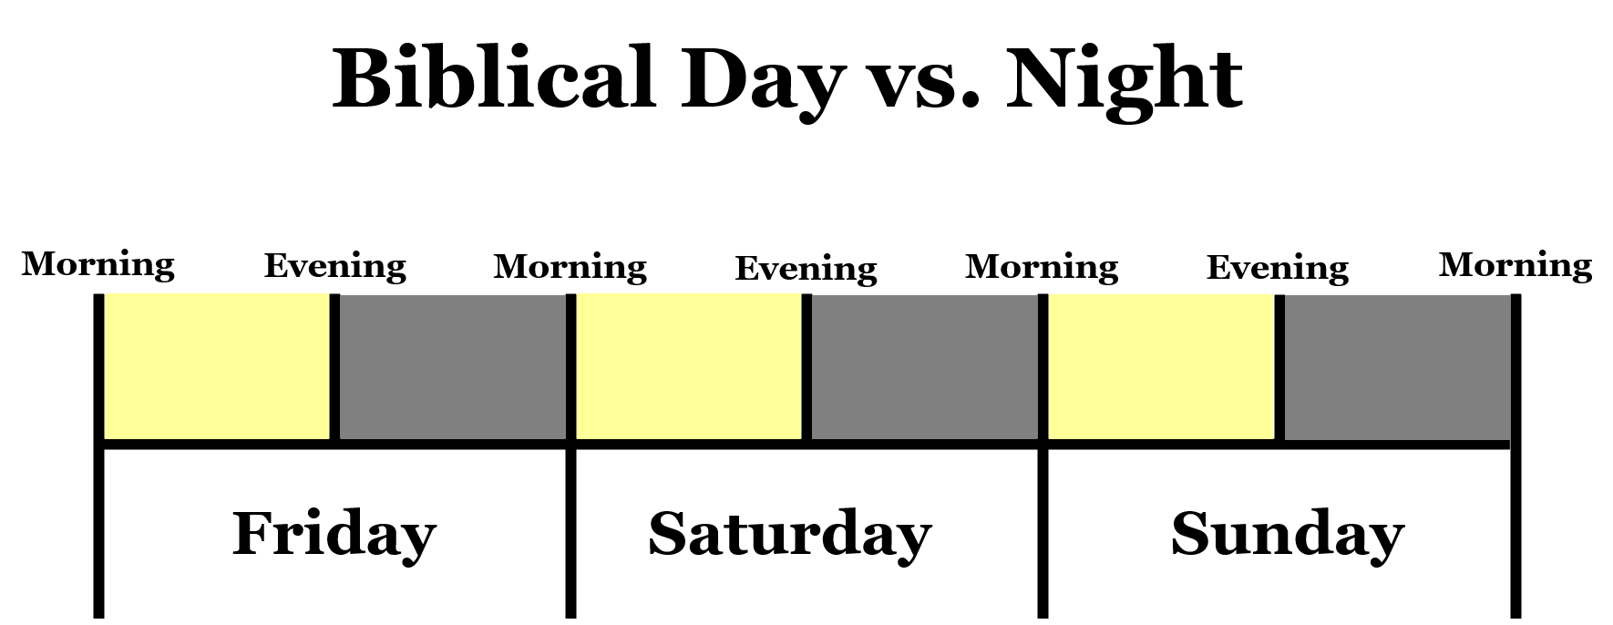

They say that they are good because they keep the Sabbath day. I am telling you right now that they don't keep the Sabbath day, physically or spiritually. They don't physically keep it because they can't get the timing right. They start it early and end it early. That means they physically break the Sabbath.

## Those That Say They Keep the Sabbath Aren't Keeping It

They don't keep the Sabbath spiritually because they believe they must keep the physical Sabbath to earn their way to heaven.

The entire point of the Sabbath day is Jessu Christ. We rest in Jesus Christ. We're only saved by Jesus Christ. We aren't saved by keeping the commandments such as physically keeping the Sabbath day and doing no work on Saturday.

Jesus is our rest. He is our Savior. He is our Sabbath.

""**Matthew 11:28-30**  
Come unto me, all ye that labour and are heavy laden, and I will give you rest. 29 Take my yoke upon you, and learn of me; for I am meek and lowly in heart: and ye shall find rest unto your souls. 30 For my yoke is easy, and my burden is light.""

When we know that the weekly Sabbath begins in the morning on Saturday, then we know that the religion of Judaism doesn't keep the Sabbath. And we know others that say they keep the Sabbath don't keep it.

We know that they don't keep the Sabbath. We know that they aren't perfect. Even if they got the day right, they still haven't kept the Sabbath their entire life.

## Remember the Sabbath Day to Keep it Holy

I ask people when out preaching the Gospel, "What do you personally believe it takes to get to heaven?" Some will say that they must keep the commandments. Let's look at one of the ten commandments in the Bible.

""**Exodus 20:8-10**  
Remember the sabbath day, to keep it holy. 9 Six days shalt thou labour, and do all thy work: 10 But the seventh day is the sabbath of the LORD thy God: in it thou shalt not do any work, thou, nor thy son, nor thy daughter, thy manservant, nor thy maidservant, nor thy cattle, nor thy stranger that is within thy gates:""

""**Exodus 20:11**  
For in six days the LORD made heaven and earth, the sea, and all that in them is, and rested the seventh day: wherefore the LORD blessed the sabbath day, and hallowed it.""

The commandment is "But the seventh day is the sabbath of the Lord thy God: in it thou shalt not do any work."

Now, you better get the seventh day correct if you think you're keeping the sabbath. And I'm telling you that the seventh day starts in the morning on Saturday and ends when the morning comes on Sunday. But the Jews don't believe that and the Seventh Day Adventists don't believe that.

So, they aren't keeping the Sabbath day because they can't understand the Scriptures.

So, I ask the people that tell me that keeping the Sabbath day gets them to heaven, I ask:

Have you always kept the Sabbath day? Have you ever done work on the Sabbath day? If they are truthful, they tell me they haven't always kept it. So, by their own admission, they aren't going to make it to heaven. All have sinned.

## We’ve Broken the Commandments So This Isn't the Way to Heaven

Keeping the commandments CAN'T be the way to heaven or no one would be there!

We should do our best to keep the commandments, but our efforts do not get us to heaven. It's the effort of Jesus Christ that gets us to heaven. It's only him and no one else.

I wanted to show you how important it is to understand when a day begins. Does a day begin in the morning, at noon, in the evening, or at midnight? I want to show you one more Scripture, and we're going to continue this study into the coming weeks.

We go back to the first time the word Sabbath is in the entire Bible and see if this makes perfect sense now that you know a day begins in the morning when the sun comes up. The beginning of the light is the beginning of a full 24-hour day. A full 24-hour day ends when the darkness ends.

Morning is the point of light. Evening is the point of darkness. Morning means light comes. Evening means darkness comes. From morning to evening, there is light. From evening to morning, there is darkness.

## A 24-Hour Day Doesn't Begin at Night

A full 24-hour day doesn't begin at night. A full 24-hour day begins in the morning.

""**Exodus 16:23-24**  
And he said unto them, This is that which the LORD hath said, To morrow is the rest of the holy sabbath unto the LORD: bake that which ye will bake to day, and seethe that ye will seethe; and that which remaineth over lay up for you to be kept until the morning. 24 And they laid it up till the morning, as Moses bade: and it did not stink, neither was there any worm therein.""

They could work on the sixth day. They couldn't work on the seventh day or the Sabbath day. They had to gather twice as much manna on the sixth day. Because TO MORROW is the rest of the sabbath unto the Lord.

They were to keep it to the next morning. The next morning is when the Sabbath day began. They were not allowed to work that next morning.

""**Exodus 16:24-26**  
And they laid it up till the morning, as Moses bade: and it did not stink, neither was there any worm therein. 25 And Moses said, Eat that to day; for to day is a sabbath unto the LORD: to day ye shall not find it in the field. 26 Six days ye shall gather it; but on the seventh day, which is the sabbath, in it there shall be none.""

When the next morning came, what does Moses say in verse 25? He says, "Eat that to day; for to day is a sabbath unto the Lord."

Understand that the Sabbath day didn't come until the next morning came. Moses says so right there. And these are the Holy Scriptures written through the Holy Spirit of God. And they kept the Sabbath correctly right there.

## A 24-Hour Day Begins in the Morning

The one thing I want you to take away from this Bible study right now is that a day begins in the morning. A day does not begin at night. And understand that the vast majority of churches will teach that a day begins at night because this comes from the false religion of Judaism. It is not a Biblical teaching.

Judaism is a false religion. A dark religion. That religion produces children of the night and not children of the day.

""**1 Thessalonians 5:4-5**  
But ye, brethren, are not in darkness, that that day should overtake you as a thief. 5 Ye are all the children of light, and the children of the day: we are not of the night, nor of darkness.""

The Scriptures are light. We find the truth in the Scriptures. And all of this works together to give us the knowledge we need to take the right path in this life. And you'll find that this simple doctrine of day vs. night will help you to understand so much more of the Bible.

Let's pray.