# Wherefore Didst Thou Doubt?

## Matthew Chapter 14:22-31

I want to look at these Scriptures in detail, and we’re going to apply this to this church, to our life, to your life. Let’s start there in verse 22 of Matthew Chapter 14.

""**Matthew 14:22**  
And straightway Jesus constrained his disciples to get into a ship, and to go before him unto the other side, while he sent the multitudes away.""

Right before this happened, Jesus fed five thousand men, beside women and children, with five loaves of bread and two fishes. No one could do something like this except for God Himself. I'm praying today that we have enough food to feed everyone who is here and everyone who is coming here today.

## Jesus Puts His Disciples Into A Ship

The disciples had just seen a great miracle. And now we see Jesus constraining his disciples to get into a ship without Him. Jesus wants them to go to the other side while He sends the multitudes of people away.

""**Matthew 14:23**  
And when he had sent the multitudes away, he went up into a mountain apart to pray: and when the evening was come, he was there alone.""

Jesus sends the multitudes of people away. And then He goes up into a mountain away from all the people to pray. By the time evening or darkness comes, Jesus was there alone in a mountain. His disciples are out in a ship on the water.

And I want you to now start thinking about all of us being His disciples in this day, this world, in this time right now that we're living in and comparing it to what's going on in that ship out on that sea. Listen closely here.

""**Matthew 14:24**But the ship was now in the midst of the sea, tossed with waves: for the wind was contrary.""

## The Disciples of Jesus Are Right in The Middle of The Sea

The disciples are right in the middle of that sea. There is no safe place close. Land is not close. They are out in the middle of that sea. "But the ship was now in the midst of the sea."

And the sea, with its waves, is tossing that ship around. The wind is fighting against the ship and the disciples within that ship.

Hey, life is tough. We're being tossed around in this world right now.

Sin is killing people all around here. We're right in the heart of Park Hill in Louisville, Kentucky. Do a search on You Tube for Park Hill Louisville, Kentucky. See what you find. I'll show you what you'll find.

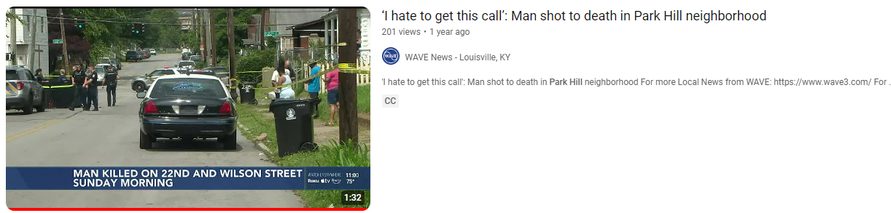

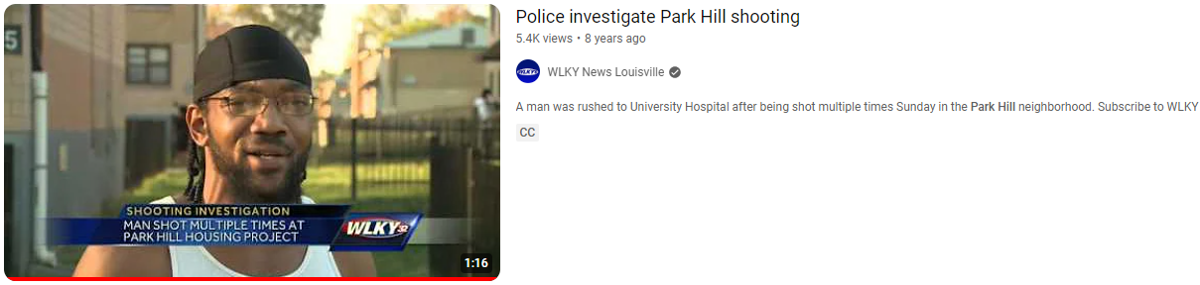

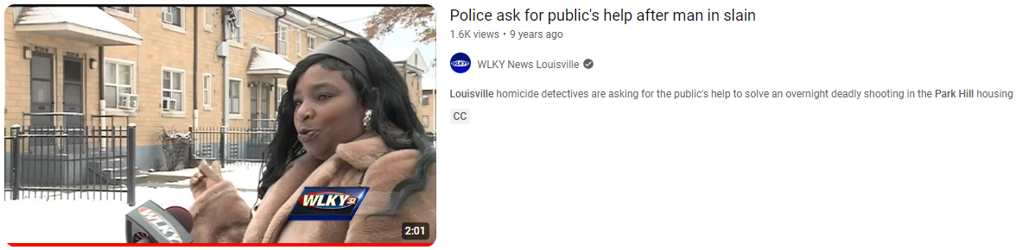

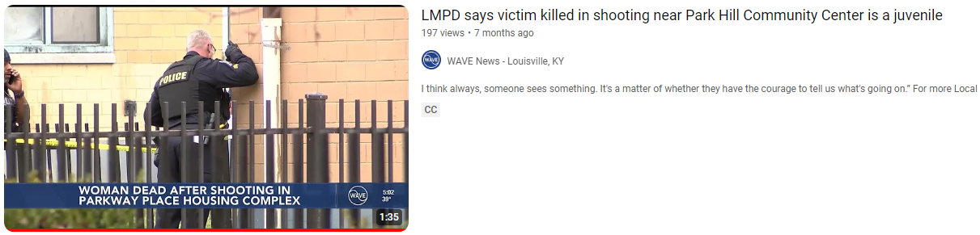

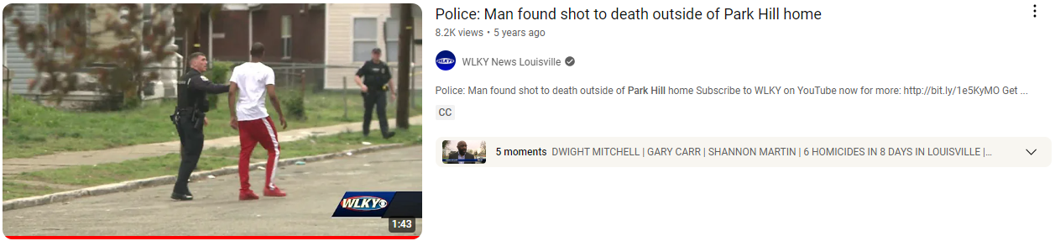

## Park Hill Louisville Is In Darkness But There's Light Here Now

You can watch and scroll through this for hours upon hours just on You Tube. You'll find things like:

"6 minors shot, 6 homicides in 8 days, teen injured in shooting during fight in Park Hill neighborhood, man charged in deadly shooting, SWAT situation after SWAT situation, shooting left 2 people dead, Mother remembers son killed in Park Hill, community asking for answers after deadly shooting in Park Hill neighborhood, Coroner identified 16-year old killed in double shooting near Park Hill"

That's what you're going to find. And that's where God put His church. God put this church here. All of this didn't just come together perfectly as it did without God. I didn't plan this church right here. Nathan knows I didn't.

But it happened. And I know God put us here. God wants the people around here in heaven. I want these people in heaven. God knows I am not afraid. God knows we will get the job done. This community wants answers. God is going to give them the answers.

## Mothers Have Been Praying For Their Children

Mothers in this neighborhood have been praying for their children. Well, God answered. He put a soul winning, Gospel preaching, Bible teaching church right here in this community.

And we need the men, women, teenagers, and children to help change this community. They own it. Let's change it.

For example, there's liquor stores everywhere around here. Stop drinking alcohol. You won't need to buy alcohol. The liquor stores will go somewhere else. There are drugs everywhere around here. Stop doing drugs. You won't need to buy drugs. The drug dealers will go somewhere else. Drugs and alcohol will kill you, kill others around you, and lead to death.

We, here in Park Hill, are right in the middle of that dark sea at night. And we will be tossed around with waves. We will have trouble. And we need your prayers. Because I'm not leaving. This is my last stop until the day I die. And I will not stop preaching the Gospel and teaching the Bible here.

## Park Hill Louisville, Kentucky Needs Your Prayers

Hey, listen, the people in Park Hill need your prayers. There's awesome people around here. I love this place. I am giving the rest of my life to this community. We've been to hundreds of their doors already and we're just getting started. These are the most humble people I've ever met in my life. I love these people here. Let's look again at verse 24.

""**Matthew 14:24**  
But the ship was now in the midst of the sea, tossed with waves: for the wind was contrary.""

Whenever we're in the Gospels of Matthew, Mark, Luke, and John, ALWAYS look for the parallel passages. That means to look for the same story in those 4 books. This same true story that we see in Matthew Chapter 14 is in Mark Chapter 6. I want to read this to you.

""**Mark 6:45-46**  
And straightway he constrained his disciples to get into the ship, and to go to the other side before unto Bethsaida, while he sent away the people. 46 And when he had sent them away, he departed into a mountain to pray.""

""**Mark 6:47-48**  
And when even was come, the ship was in the midst of the sea, and he alone on the land. 48 And he saw them toiling in rowing; for the wind was contrary unto them: and about the fourth watch of the night he cometh unto them, walking upon the sea, and would have passed by them.""

## Jesus Saw His Disciples Laboring In Pain

Hey, his people, his disciples were out in the middle of that dark sea. Verse 48, look closely. "And he saw them toiling in rowing." Toiling means laboring in pain. They were out there working hard. And Jesus was watching them.

Understand this. Jesus is God. He's watching over us. It's not people who are dead watching over us. Jesus is watching over us.

To the evil out there who may try to stop us and come against us. Understand Jesus, the ALMIGHTY GOD of all Creation, is watching. Be careful out there. That's why I'm not afraid. I know who is watching over us here at this church right in the heart of Park Hill.

We go out and work hard in these neighborhoods. We go out and drip sweat. And we're going to keep dripping sweat and we're going to shed tears with the people in these neighborhoods. We're going to lose some, but we're going to win many.

We toil and labor in pain for our Lord who worked much harder than we could ever understand. He gave it all for us. We'll give Him everything we've got. Let's go back to Matthew Chapter 14 and continue in verse 25 where we left off.

## Jesus Went To His Disciples, Walking On Water

""**Matthew 14:25**  
And in the fourth watch of the night Jesus went unto them, walking on the sea."

It's the fourth watch of the night now. That's been a while since even was come. They were toiling for a long time. They were working hard for a long time. Hey, we show Jesus we love Him by continuing to do His work even when it's tough. When we don't think we can go on, we keep going.

Jesus comes to them walking on the sea. Imagine that. Working hard. Laboring in pain. And you see something out there walking towards you in the middle of the sea.

""**Matthew 14:26**  
And when the disciples saw him walking on the sea, they were troubled, saying, It is a spirit; and they cried out for fear.""

They were troubled. We're going to be troubled at times, many times. His disciples thought it was a spirit or a ghost. THEY CRIED OUT FOR FEAR. I know for a fact many of you here right now are afraid of this area. We’re all afraid at times. We all get scared at times. We all cry out for fear at times.

## Jesus Isn't Afraid, We Are Not Afraid

But then we see Jesus show up. And Jesus speaks. I can guarantee you He isn't afraid at any time.

""**Matthew 14:27**  
But straightway Jesus spake unto them, saying, Be of good cheer; it is I; be not afraid.""

The Gospel of Mark says the same thing.

""**Mark 6:50**For they all saw him, and were troubled. And immediately he talked with them, and saith unto them, Be of good cheer: it is I; be not afraid.""

He wasn't there to trouble them. He spoke immediately and said, "Be of good cheer: it is I; BE NOT AFRAID."

Hey, Jesus Christ tells us to be of good cheer. Do you know what will make you happy? Jesus Christ. Following Him. Doing what He's asked you to do. Believing in Him first. Putting all your trust in Him alone for salvation.

What can wash away my sins? NOTHING BUT THE BLOOD OF JESUS. If you want to go to heaven, you only get there through Jesus. Put your trust in Him right now to save you, and He says I'll save you right now. No more fear of hell.

## Get Saved, Get Baptized, Come to Church, Increase Faith and Good Works

After you're saved, get baptized. We'll baptize you here. It's the first step in showing Jesus that you want to obey Him and to live your life for Him.

The best life to live is in a good church preaching the Gospel to your community, attending church, increasing your faith in God by hearing His words, hearing good preaching, hearing preaching against sin such as alcohol, drugs, fornication, adultery, and having GOOD CHEER.

Jesus says, "Be of good cheer: IT IS I; Be not afraid."

Hey, that's comforting. When you're here with us, this will be a place of comfort and safety. This church is owned and operated by the Lord Jesus Christ.

""**Isaiah 43:1-2**  
But now thus saith the LORD that created thee, O Jacob, and he that formed thee, O Israel, Fear not: for I have redeemed thee, I have called thee by thy name; thou art mine. 2 When thou passest through the waters, I will be with thee; and through the rivers, they shall not overflow thee: when thou walkest through the fire, thou shalt not be burned; neither shall the flame kindle upon thee.""

## We Can Feed You Spiritually

Jesus will be with us here. I won't be able to feed you physical food all the time. I won't be able to give you money all the time. But I will be able to feed you spiritual things from God's word that are far greater than physical things. I will teach you how to win souls to Christ. I want to help you get rewards in heaven for doing what Jesus asked you to do. I'll show you how to do it.

And, if you've believed in the Lord Jesus Christ for salvation, I will see you in heaven no matter what happens here.

But our job is not be afraid and to go out there and get people to heaven. Once they know they're going to heaven, our job is to get them baptized, and to get them here into this church so they can help get others to heaven. We need your help out there.

If there's 14 of us going out today to preach the Gospel, we might get 10 people saved in this community. But if we have 100 people, we might get 75 people saved. Jesus wants the 75. Jesus wants more and more. Jesus wants all these people out here in Park Hill and beyond in Louisville saved.

## The Will of God Is For All Of Park Hill Louisville To Be Saved

We know Jesus is with us. We know that we aren't self-willed. We are following the will of God. His will is for everyone here and everyone out there to be saved.

""**Mark 6:48**  
And he saw them toiling in rowing; for the wind was contrary unto them: and about the fourth watch of the night he cometh unto them, walking upon the sea, and would have passed by them.""

Jesus walked upon the sea. He is the light in the darkness. Darkness is scary. I've been out on U.S. Navy ships in the middle of the sea. And I couldn't see my hand in front of me. It was scary.

But Darkness can't comprehend Jesus Christ. This church is going to be the light in this Park Hill neighborhood. The people will know they can come here for safety. They can come here when one of their loved ones is shot and killed. We'll cry with them, and we'll try to do better so the next loved one isn't shot and killed.

""**Matthew 5:14-15**  
Ye are the light of the world. A city that is set on an hill cannot be hid. 15 Neither do men light a candle, and put it under a bushel, but on a candlestick; and it giveth light unto all that are in the house.""

## This Church Is The Light In The Darkness

We aren't going to hide out here. This church will be the light in the darkness here. Some people will love us. Others will hate us. Which side are you going to be on? You want to be on the side of Jesus Christ. He can be the scariest of all, and you don't want no part of the wrath of Jesus Christ.

We're going to let that light shine here. A city that is set on a hill cannot be hid. We will not be hidden. We will go out as Jesus commanded and preach the Gospel. We rely on God to protect us. And He already has, for years, as we've been to some dangerous areas before. And He will continue to protect us as we're out there toiling, laboring in pain, for Him and through Him.

We aren't hiding. We're going to put the light out there on a candlestick, and we're going to give that light unto all that are in the house.

Hey, you made a great decision to come here today. If you aren't saved today, now is the time. Today is the day of salvation. It's time to change your future forever.

""**John 8:12**  
Then spake Jesus again unto them, saying, I am the light of the world: he that followeth me shall not walk in darkness, but shall have the light of life.""

## Get Out of the Darkness and Into the Light of Jesus Christ

We might be in a dark place in this physical world, but we're changing all that today. Get saved today and forever. Receive everlasting life today. But don't stop with yourself. Let's take that light out to this dark area and get them everlasting life too. Jesus says, "He that followeth me shall not walk in darkness, but shall have the light of life."

Yeah, it's scary out there. Yeah, it's dark out there. But we've got Jesus!!! And He is the light in the darkness. He is gracious, and full of compassion, and righteous. I'm going back to Matthew Chapter 14 and continuing there.

""**Matthew 14:27-29**  
But straightway Jesus spake unto them, saying, Be of good cheer; it is I; be not afraid. 28 And Peter answered him and said, Lord, if it be thou, bid me come unto thee on the water. 29 And he said, Come. And when Peter was come down out of the ship, he walked on the water, to go to Jesus.""

Hey, let me ask you something. Do you believe the Bible? Do you believe the word of God?

Do you see what happened right there? Hey, take a step of faith. Peter says, "Lord, if it be thou, bid me come unto thee on the water." Peter knew that Jesus could do anything. Do you know that?

## What Are You All Doing In Park Hill? Why Do You Want To Be Here?

Many people have said, "What are you all doing in Park Hill?" The police shake their heads at us.

Others have said, "Do you know where you are?" Yeah, I do know where I'm at. I'm right here where God put me. I went through some things to get here. I would have never came here before I went through some other things. God had the plan. I didn't. I told Him I would go wherever He wanted me to go. And I'm here. And I'm not leaving.

Hey, have some faith. Take the step. Get into this church and God will show Himself strong as He always does. As Jesus does in this Scripture here. Peter took that step of faith.

"And when Peter was come down out of the ship, HE WALKED ON THE WATER, to go to Jesus."

Do you believe that? That's amazing. Peter walked on the water. How? By faith. Jesus said, "Peter, come." The Lord is calling you today.

""**Matthew 11:28**  
Come unto me, all ye that labour and are heavy laden, and I will give you rest.""

## You Don't Want To Be On The Other Team Opposite of Jesus

Jesus wants you on His team. You don't want to be on the other team. I've been there before. You'll end up dead really fast on that other side. That's what the other side wants for you. Jesus wants good for you. He loves you. He gave you life. He has all power.

He says, "Come unto me, all ye that labour and are heavy burden, and I will give you rest." And He doesn't lie to you. He's never told one lie. You and I have. He hasn't. You need help. Jesus is ready. Always ready.

Hey, I'm calling you today too. Come help us here at this church. We will do the work of God and there is no greater work than that. You will hear about this church. You will hear about the work we are doing here. Be a part of it please.

Peter took that step of faith. Nathan took that step of faith. Milana took that step of faith. Their children are taking those steps. My Dad. My Mom. My wife. My kids. We're stepping in faith here at this church. We need more. Come join us.

## It's Time To Take That Step of Faith

Peter stepped out there. He walked on water. Yeah, it happened. A man walked on water with God holding him up.

And now we're to the important part of the sermon. The title of the sermon is "Wherefore Didst Thou Doubt? Wherefore Didst Thou Doubt?"

I want you to see this. I'm going back to Matthew Chapter 14. Peter is walking on water. He trusts Jesus.

""**Matthew 14:29-30**  
And he said, Come. And when Peter was come down out of the ship, he walked on the water, to go to Jesus. 30 But when he saw the wind boisterous, he was afraid; and beginning to sink, he cried, saying, Lord, save me.""

Peter was walking on the water. He was following Jesus. He was going to Jesus.

## Peter Was Afraid

"But when he saw the wind boisterous, he was afraid." Hey, we all have those times in our life. I've had some of them. You've had some of them. You might be having those times right now. Maybe that's why you're here. Maybe that's why you decided to listen when we brought the Gospel to you.

People without problems don't usually need God. And they don't want to hear the Gospel.

People ask, "Why are you here in Park Hill?" Hey, because the wind is boisterous. Because the people are afraid. Because the people are beginning to sink. Because the people are crying out just as Peter cried out: "LORD, SAVE ME."

We're here to bring the Gospel of the Lord Jesus Christ to the people who want to hear it. To the people who see their neighbors dying.

One young lady in Park Hill told my wife she wanted to be saved because she didn't know when she would be taken out next. The people are afraid of the darkness. We bring the light of Jesus Christ, and they want Jesus Christ. They want salvation.

## The People Here Want To Know How To Get To Heaven

They ask us to please show them. They say, "Hey, I want to know how to get to heaven."

I've been to many other neighborhoods. I've been to many other cities. I've never been to one like this. They're hurting. They're afraid. They need help. We're here to help. We're here to get them on the right track. And we will do that.

Peter was afraid out there on that dark, windy sea. He began to sink. He asks Jesus to save him.

Hey, did you know that if you believe Jesus can save you right now from all your sins, past, present, and future, that He will do that right now? Say, "Jesus I believe in you. I know you can save me right now. Please save me." If you believe that, He's waiting right now to save you.

He offers you everlasting life right now. When your body dies, your soul will go straight to heaven to be with the Almighty Lord and Savior Jesus Christ. Everlasting means everlasting. You get everlasting life right now. Jesus is telling you, "It never going to end."

## Believe That Jesus Can Save You

Believe that Jesus can save you. Ask Jesus to save you. He hears your thoughts.

Let's see what happens to Peter. He calls out for Jesus to save him: "Lord, save me." What happened?

""**Matthew 14:31-32**  
And immediately Jesus stretched forth his hand, and caught him, and said unto him, O thou of little faith, wherefore didst thou doubt? 32 And when they were come into the ship, the wind ceased.""

Notice what the Bible says right there at the beginning of the verse. "And immediately" Jesus stretches forth His hand and caught Him. If you ask Jesus to save you, by faith alone in Him, IMMEDIATELY He saves you for all eternity.

Peter had faith in Jesus. But he let that boisterous or loud, roaring, and violet wind trouble him. We're going to have those violent people trying to stop us. We're going to have the spiritual powers of darkness trying to stop us.

That little bit of faith in Jesus Christ saves us.

## Don't Sink As You Follow Jesus Christ

But, hey, I don't want to sink as I'm following the Lord Jesus Christ because I doubted. And yes, people doubt us here. What are you thinking coming here? But you know who didn't doubt us? Pastor Tim DeVries didn't doubt us. And I'll remember that. Vision Valley Baptist Church didn't doubt us. I'll remember that.

I thank God for Pastor Tim DeVries and Vision Valley Baptist Church in Mt. Washington, Kentucky. They want the people here saved. And they sent us here to get it done. And we will.

Jesus Christ definitely doesn't doubt us. He put us here. I know He did. He worked all of this out.

Hey, don't doubt us here. If you do, you don't know us. Come and find out. I haven't stopped working for God since I was saved, and I'm not stopping now. The Holy Spirit is here. We ask Him to lead us each day. Take us to the right people. And He always does. He protects us. He keeps us safe.

And I don't doubt.

## Wherefore Didst Thou Doubt

"O thou of little faith, wherefore, didst thou doubt?"

And I know the people who are here right now don't doubt us. That's why you're here. And I thank all of you from the bottom of my heart for being here to support us. So thankful. So Peter had faith. But he doubted. He asks Jesus to save him. Jesus did. And I am sure we're going to be asking for Jesus to save us out of many things here at this church.

""**Matthew 14:32-33**  
And when they were come into the ship, the wind ceased. 33 Then they that were in the ship came and worshipped him, saying, Of a truth thou art the Son of God.""

Hey, look, when Jesus came into the ship, the wind ceased. The wind obeys the Lord Jesus Christ. It doesn't care what I say or do. But when Jesus stepped in, the wind stopped. Jesus can protect us. He will protect us.

When someone wants to kill me, which I'm sure they do already, Jesus can calm that wind.

## Jesus Is Running This So Don't Doubt Us

We've got to know who is running this. It's the Lord Jesus Christ who created everything you see. It's all His. He's running things.

""**Romans 8:31**  
What shall we then say to these things? If God be for us, who can be against us?""

And I know for sure that God is for us here because we go out and do the work He asked us to do. He is for that. And we aren't going to stop doing that work for Him. That work doesn't save us. We're already saved. But it saves others. We show the love of Jesus Christ by doing what He says.

Don't doubt what the Lord Jesus Christ can do. Some will say, "This area will never change." If I was a betting man, I would say: "You want to bet?" Hey, I'm telling you right now this area is going to change for the good. I have no doubt AT ALL.

There's going to be saved people all over the place out there. And we're going to do our best to get them to do the works of God, change their life, and get more and more people to heaven.

Don't doubt us. Believe in us here. Pray for us. Please. Help us. Remember us.

Let's pray.